# **Angular Program to create form with real time updations**

**Exercise-6**

**Date:06-05-2022**

**Aim:**

To write an angular program to create form with real time updations.

**Procedure:**

* First we create a database & table in PHP.
* Next we create a php file in a folder inside wamp64 folder.
* Connect the php file with the database using -mysqli_connect() specifying our system host name,database user id and password correctly-$con=mysqli_connect(‘127.0.0.1’,’root’,’db_con’,’mydb’);
* using mysqli_query( $con,$sql) we create the database.
* Insert into database.
* We connect the php file to our main file using <form ng-app=”myapp” ng-controller=”formcontroller”.
* Insert all the values to the database.
* Disply the values in the database.

**Code:**

**Index.php**

<!DOCTYPE html>

<html>

<head>

<title>Webslesson Tutorial | Submit Form Data by using AngularJS with Validation using PHP</title>

<link rel="stylesheet" href="https://maxcdn.bootstrapcdn.com/bootstrap/3.3.6/css/bootstrap.min.css" />

<script src="http://ajax.googleapis.com/ajax/libs/angularjs/1.4.8/angular.min.js"></script>

<script src="app.js"></script>

</head>

<body>

<br><br>

<div class="container" style="width:750px;">

<h3 align="center">Submit Form Data by using AngularJS with Validation using PHP</h3>

<br><br>

<div ng-app="myapp" ng-controller="formcontroller">

<form name="userForm" ng-submit="insertData()">

<label class="text-success" ng-show="successInsert">{{successInsert}}</label>

<div class="form-group">

<label>First Name <span class="text-danger">*</span></label>

<input type="text" name="first_name" ng-model="insert.first_name" class="form-control" />

<span class="text-danger" ng-show="errorFirstname">{{errorFirstname}}</span>

</div>

<div class="form-group">

<label>Last Name <span class="text-danger">*</span></label>

<input type="text" name="last_name" ng-model="insert.last_name" class="form-control" />

<span class="text-danger" ng-show="errorLastname">{{errorLastname}}</span>

</div>

<br>

<div class="form-group">

<input type="submit" name="insert" class="btn btn-info" value="Insert"/>

</div>

</form>

<input type="submit" name="submit1" value="display">

</div>

</div>

</body>

</html>

**Insert.php**

<?php

//insert.php

$connect = mysqli_connect("localhost", "root", "", "testing");

$form_data = json_decode(file_get_contents("php://input"));

$data = array();

$error = array();

if(empty($form_data->first_name))

{

$error["first_name"] = "First Name is required";

}

if(empty($form_data->last_name))

{

$error["last_name"] = "Last Name is required";

}

if(!empty($error))

{

$data["error"] = $error;

}

else

{

$first_name = mysqli_real_escape_string($connect, $form_data->first_name);

$last_name = mysqli_real_escape_string($connect, $form_data->last_name);

$query = "

INSERT INTO tbl_user(first_name, last_name) VALUES ('$first_name', '$last_name')

";

if(mysqli_query($connect, $query))

{

$data["message"] = "Data Inserted...";

}

}

// echo json_encode($data);

$row=array();

$sql = "SELECT * FROM tbl_user";

$result = mysqli_query($conn,$sql);

if($result){

while($r = mysqli_fetch_assoc($result)) {

$rows[] = $r;

}

print json_encode($rows);

}

?>

**App.js**

var app = angular.module("myapp", []);

app.controller("formcontroller", function($scope, $http){

$scope.insert = {};

$scope.insertData = function(){

$http({

method:"POST",

url:"insert.php",

data:$scope.insert,

}).success(function(data){

if(data.error)

{

$scope.errorFirstname = data.error.first_name;

$scope.errorLastname = data.error.last_name;

$scope.successInsert = null;

}

else

{

$scope.insert = null;

$scope.errorFirstname = null;

$scope.errorLastname = null;

$scope.successInsert = data.message;

}

});

}

});

**Output:**

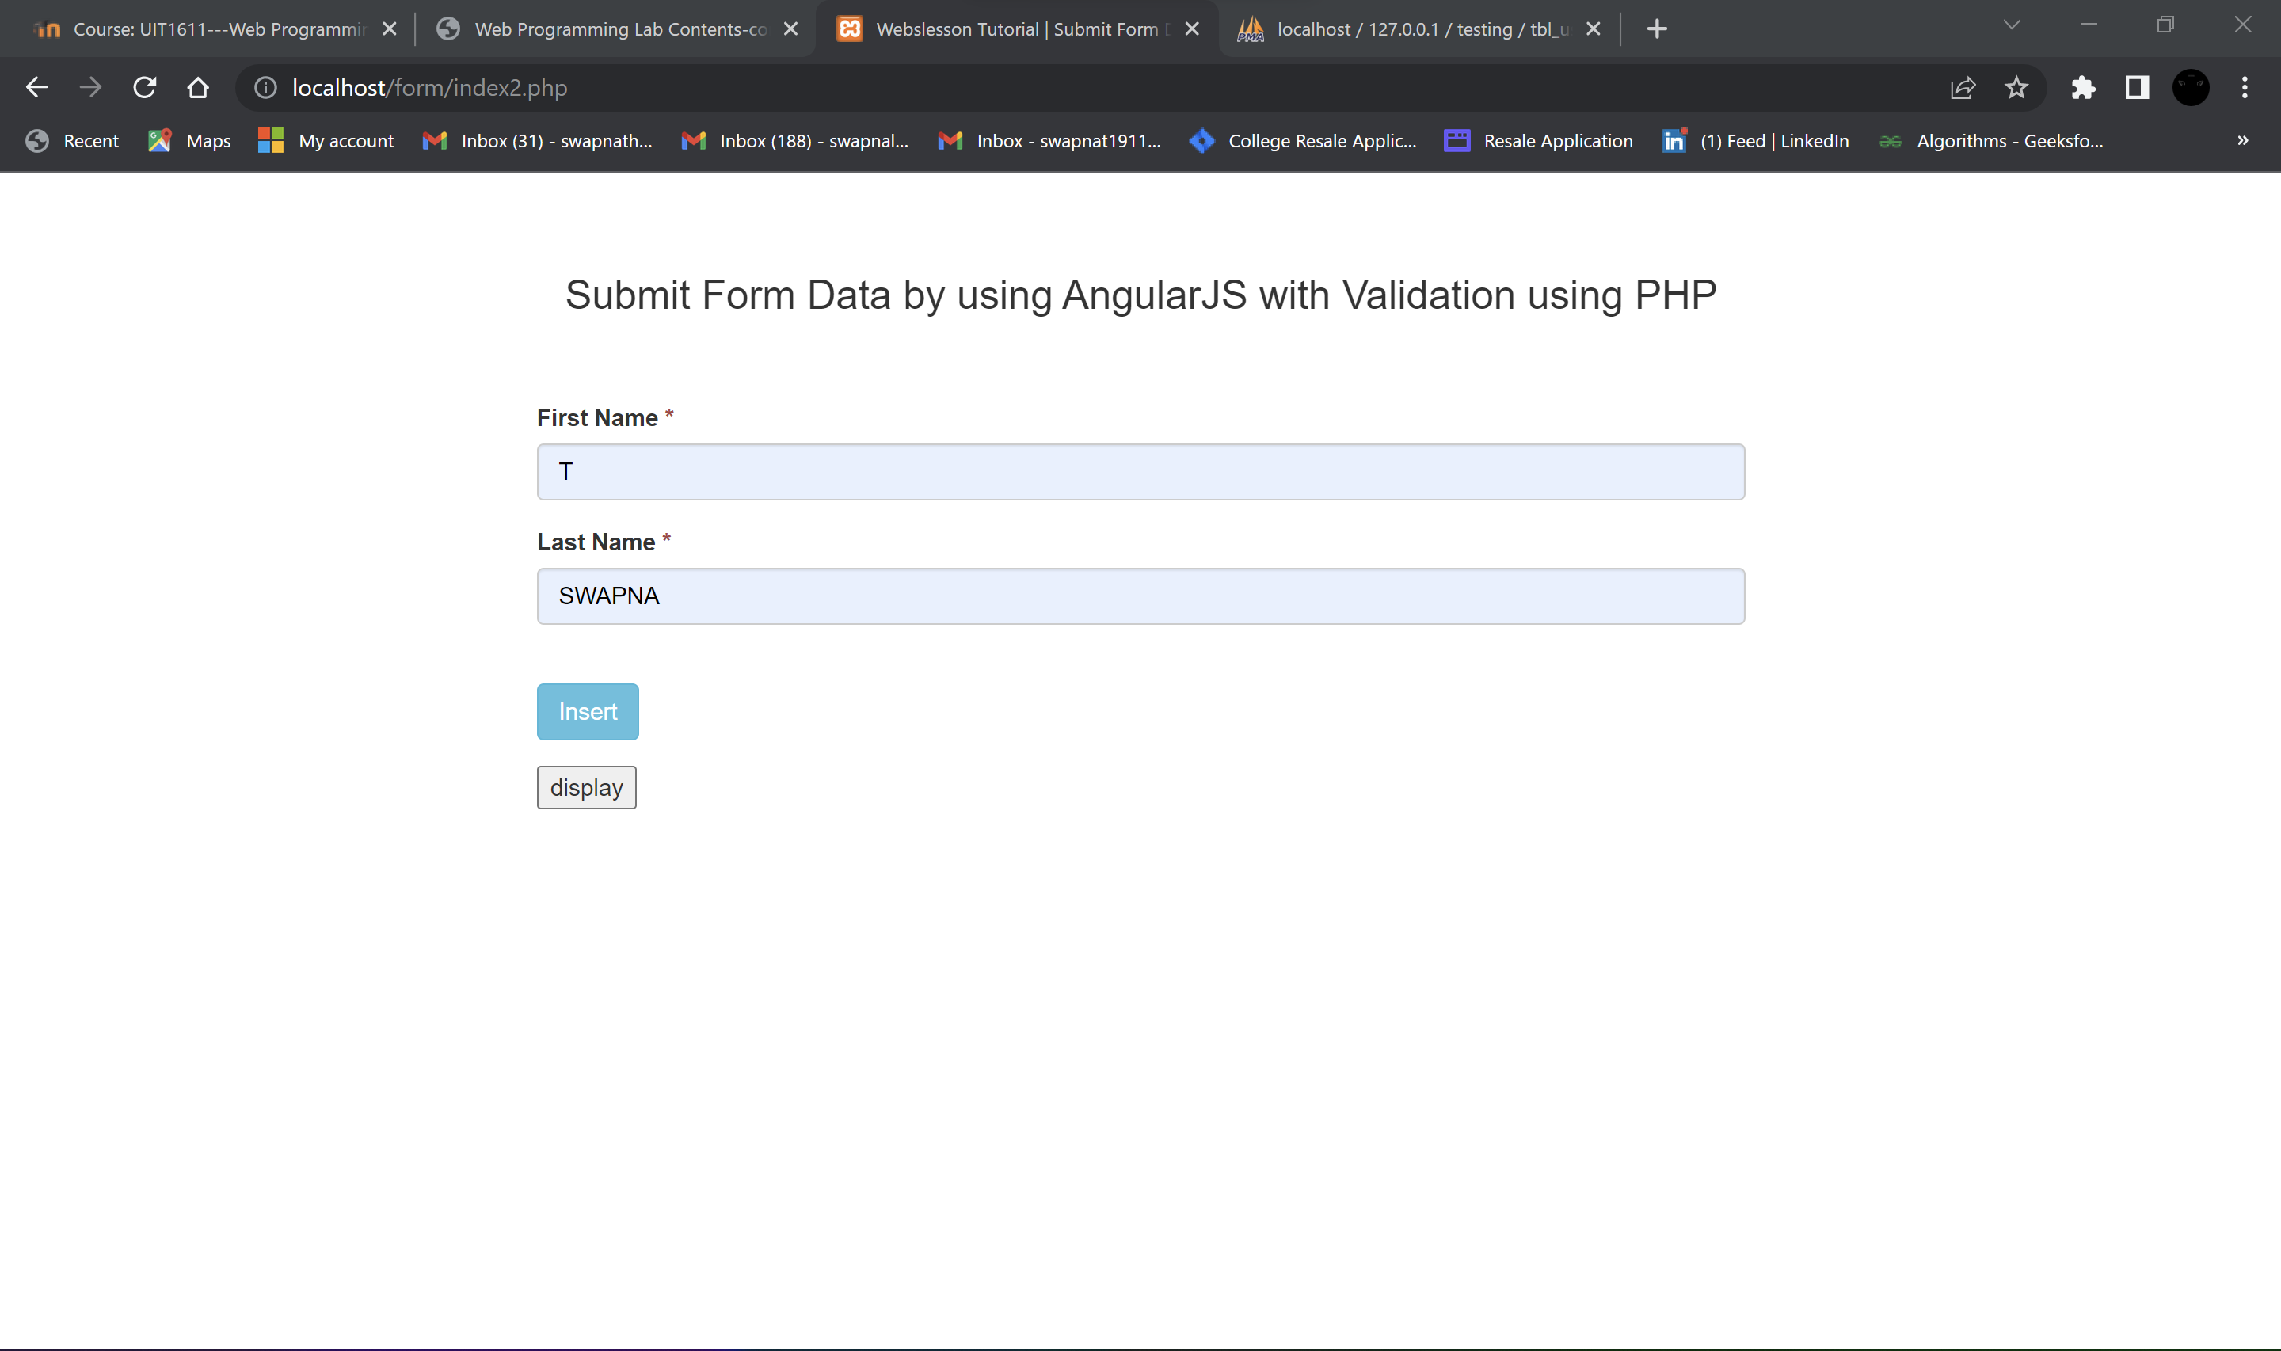

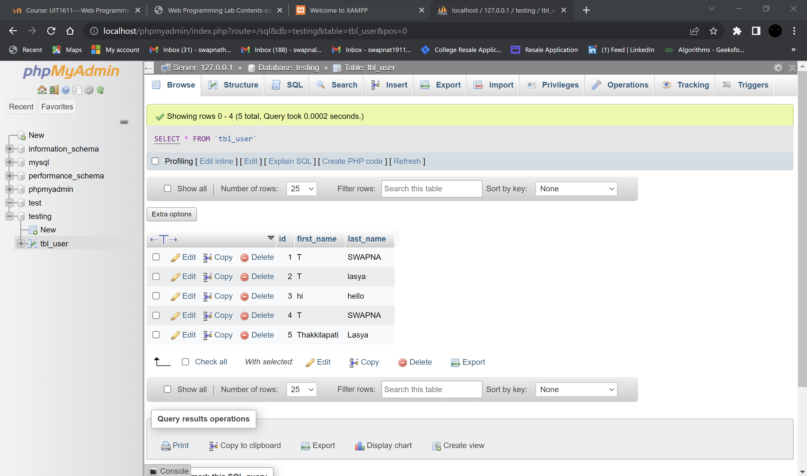

**Result:**

The above code was successfully executed to implement form with real time updations.

# **Video player using Angular JS**

**Exercise-7**

**Date:24-05-2022**

**Aim:**

To implement video player using angular JS.

**Procedure:**

* Initialize an Angular JS application using ‘ng-app’ directive <body ng-app=”myApp” ng-controller=”myctrl”>
* Call controller functions defined within <script> for ever action required on click using ‘ng-click’-<button ng-click=”playvid()”><I class=”fa fa-play”></i></button>.
* Here, <i class="fa fa-play"> we use <i> icon tag to display video buttons using FontAwesome icons (fa) by including <link rel="stylesheet" href="https://cdnjs.cloudflare.com/ajax/libs/font-awesome/4.7.0/css/fontawesome.min.css"> in header.
* Add the video using <video > tag - <video id="video1" width="420" height="300">
* <source src="sample.mp4" type="video/mp4"> </video>.
* Using DOM we extract the video element- var vid= document.getElementById ("video1");
* Define every action required using video control function like pause() ,play() , .currentTime , .muted , .playbackRate etc..

**Code:**

**Index.html**

<!DOCTYPE html>

<html lang="en">

<head>

<meta charset="UTF-8">

<meta http-equiv="X-UA-Compatible" content="IE=edge">

<meta name="viewport" content="width=device-width, initial-scale=1.0">

<title> Angular Video Editor </title>

<link rel="stylesheet" href="https://cdnjs.cloudflare.com/ajax/libs/font-awesome/4.7.0/css/font-awesome.min.css">

<script src="https://ajax.googleapis.com/ajax/libs/angularjs/1.6.9/angular.min.js"></script>

<script src="script.js"></script>

<link rel="stylesheet" href="styles.css">

</head>

<body ng-app="myApp" ng-controller="myCtrl">

<h1>VIDEO PLAYER USING ANGULAR JS</h1>

<video id="myVdo">

<source src="sample.mp4" type="video/mp4">

Your browser does not support the video tag.

</video>

<br><br>

<center>

<button ng-click="play_vdo()">

<i class="fa fa-play"></i>

</button>

<button ng-click="pause_vdo()">

<i class="fa fa-pause"></i>

</button>

<button ng-click="maximize()">

<i class="fa fa-expand"></i>

</button>

<button ng-click="mute_ado()">

<i class="fa fa-volume-off"></i>

</button>

<button ng-click="unmute_ado()" >

<i class="fa fa-volume-up"></i>

</button>

<button ng-click="speed_ctrl()">

2x

</button>

</center>

</body>

</html>

**Script.js**

var app = angular.module("myApp",[]);

app.controller("myCtrl",function($scope){

var ele = document.getElementById("myVdo");

$scope.play_vdo = function(){

ele.play();

}

$scope.pause_vdo = function(){

ele.pause();

}

$scope.maximize = function(){

ele.requestFullscreen();

}

$scope.mute_ado = function(){

ele.muted = true;

}

$scope.unmute_ado = function(){

ele.muted = false;

}

$scope.speed_ctrl = function(){

ele.playbackRate = 2;

}

});

**Styles.css**

img{

width: 50px;

height: 50px;

}

button{

background: transparent;

}

video{

margin-left: 30px;

margin-right: 30px ;

display: block;

max-width: 100%;

}

h1{

text-align: center;

}

**Output:**

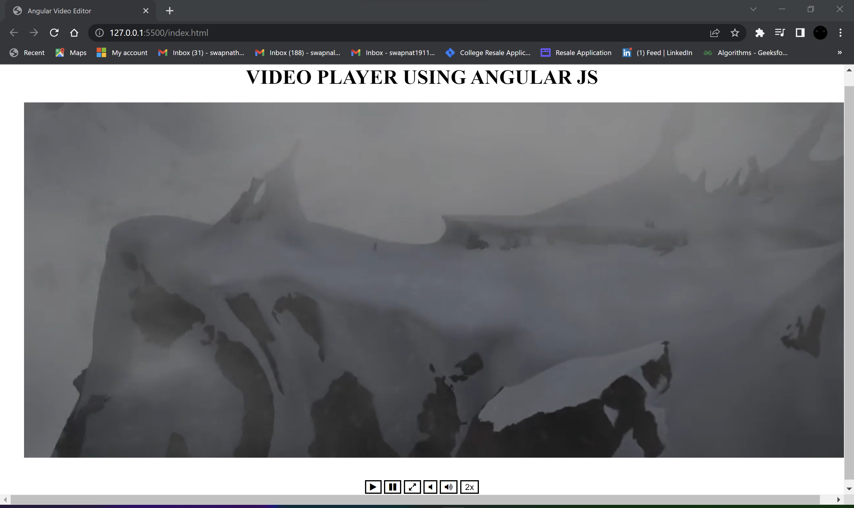

**Result:**

Thus, the video player is implemented using Angular JS.

# **Text editor using Angular JS**

**Exercise-8**

**Date:02-06-2022**

**Aim:**

To implement text editor using angular JS.

**Procedure:**

* Create a drop down list using <select> and <option> to display the operations that editor can perform – New, Open, Save , Cut , Copy , Paste etc..
* Using ‘ng-click’ we call appropriate functions defines within <script> to perform the actions.
* For saving the file we use blob() Web API that stores the data into the blob.
* Convert the blob (text ) to URL using URL.createObjectURL() method. This method takes a
* Blob (or Blob-like object) and returns a String that can be used in any place that a URL might be used (such as an HREF attribute).
* Load a file to the editor using var FileReader() Web API.
* Cut, Copy and Paste using document.execCommand() Web APIdocument.execCommand("Copy"); & navigator.clipboard which returns the Clipboard object used to read and write the clipboard's contents.
* Exit from the editor using window.close().

**Code:**

**Index.html**

<!DOCTYPE html>

<html lang="en">

<head>

<meta charset="UTF-8">

<meta http-equiv="X-UA-Compatible" content="IE=edge">

<meta name="viewport" content="width=device-width, initial-scale=1.0">

<title>Text Editor using AngularJs</title>

<link rel="stylesheet" href="https://cdnjs.cloudflare.com/ajax/libs/font-awesome/4.7.0/css/font-awesome.min.css">

<script src="https://ajax.googleapis.com/ajax/libs/angularjs/1.6.9/angular.min.js"></script>

<script src="script.js"></script>

<link rel="stylesheet" href="styles.css">

</head>

<body ng-app="">

<div id="bordering">

<select ng-model="myVar">

<option value="" disabled selected>FILE</option>

<option value="new">new</option>

<option value="open">open</option>

<option value="save as">save as</option>

<option value="exit">exit</option>

</select>

<select id= "select" onchange="edit()" ng-model="myvar1">

<option value="" disabled selected>EDIT</option>

<option value="cut">cut</option>

<option value="copy">copy</option>

<option value="paste">paste</option>

</select>

<div ng-switch="myVar">

<table>

<tr>

<td>Text to Save:</td>

</tr>

<tr>

<td colspan="3">

<textarea id="inputTextToSave" cols="80" rows="25" ngcopy="copied=true" ng-paste="paste=true" ng-cut="cut=true" ></textarea>

</td>

</tr>

</table>

<div ng-switch-when="new">

<button><a href="C:\Users\swapna\Desktop\sem-6-web-project\BOOK_THRIFT\ex-8-texteditor">new</a> </button>

</div>

<div ng-switch-when="save as">

Filename to Save As:

<input id="inputFileNameToSaveAs"></input>

<button onclick="saveTextAsFile()">Save Text to File</button>

</div>

<div ng-switch-when="open">

<table>

<tr>

<td>Select a File to Load:</td>

<td><input type="file" id="fileToLoad"></td>

<td><button onclick="loadFileAsText()">Load Selected File</button><td>

</tr>

</table>

</div>

<div ng-switch-when="exit">

<button class="btn btn-alt a1" onclick = "exitFile()" id = "exitFile">Close

File

</button>

</div>

</div>

<div ng-switch="myvar1">

<p>You have copied: <b>{{copied}}</b></p>

<p>You have pasted in Textbox: <b>{{paste}}</b></p>

<p>You have cut from Textbox: <b>{{cut}}</b></p>

<div ng-switch-when="copy">

<button class="btn btn-alt a1" onclick = "copytoClipboard()" id ="copy">Copy</button>

</div>

<div ng-switch-when="paste">

<button class="btn btn-alt a1" onclick = "pastetoClipboard()" id ="paste">Paste</button>

</div>

<div ng-switch-when="cut">

<p><button class="btn btn-alt a1" onclick = "cuttoClipboard()" id ="cut">Cut</button>

</div>

</div>

</body>

</html>

**Script.js**

$scope.cut = false;

$scope.copy = false;

$scope.paste = false;

function saveTextAsFile()

{

var textToSave = document.getElementById("inputTextToSave").value;

var textToSaveAsBlob = new Blob([textToSave], {type:"text/plain"});

var textToSaveAsURL = window.URL.createObjectURL(textToSaveAsBlob);

var fileNameToSaveAs = document.getElementById("inputFileNameToSaveAs").value;

var downloadLink = document.createElement("a");

downloadLink.download = fileNameToSaveAs;

downloadLink.innerHTML = "Download File";

downloadLink.href = textToSaveAsURL;

downloadLink.onclick = destroyClickedElement;

downloadLink.style.display = "none";

document.body.appendChild(downloadLink);

downloadLink.click();

}

function destroyClickedElement(event)

{

document.body.removeChild(event.target);

}

function loadFileAsText()

{

var fileToLoad = document.getElementById("fileToLoad").files[0];

var fileReader = new FileReader();

fileReader.onload = function(fileLoadedEvent)

{

var textFromFileLoaded = fileLoadedEvent.target.result;

document.getElementById("inputTextToSave").value = textFromFileLoaded;

};

fileReader.readAsText(fileToLoad, "UTF-8");

}

function edit()

{

var x = document.getElementById("select").value;

document.getElementById("demo").innerHTML = x + " successful !!";

}

function copytoClipboard()

{

var textArea = document.getElementById("inputTextToSave");

textArea.select();

document.execCommand("Copy");

}

function cuttoClipboard()

{

var textArea = document.getElementById("inputTextToSave");

textArea.select();

document.execCommand("Cut");

}

function pastetoClipboard()

{

let pasteArea = document.getElementById('inputTextToSave');

navigator.clipboard.readText()

.then((text)=>{pasteArea.value+='\n'+ text;

})

}

function exitFile()

{

window.close();

}

**Output:**

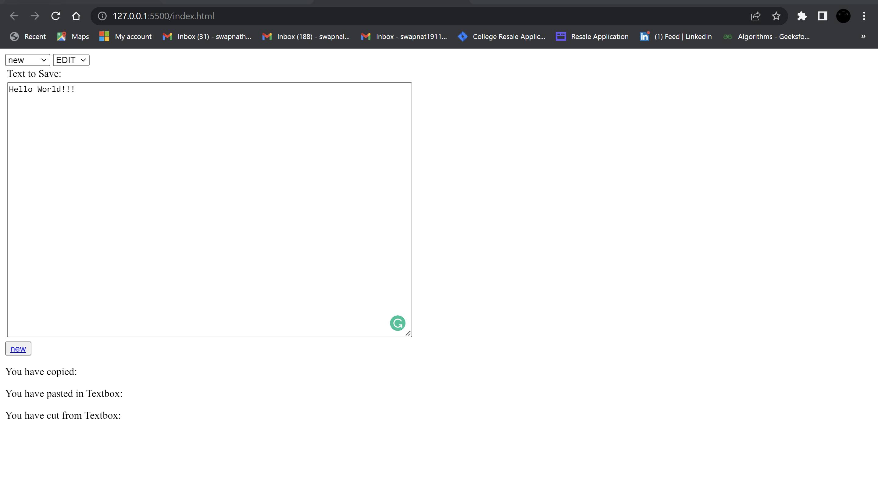

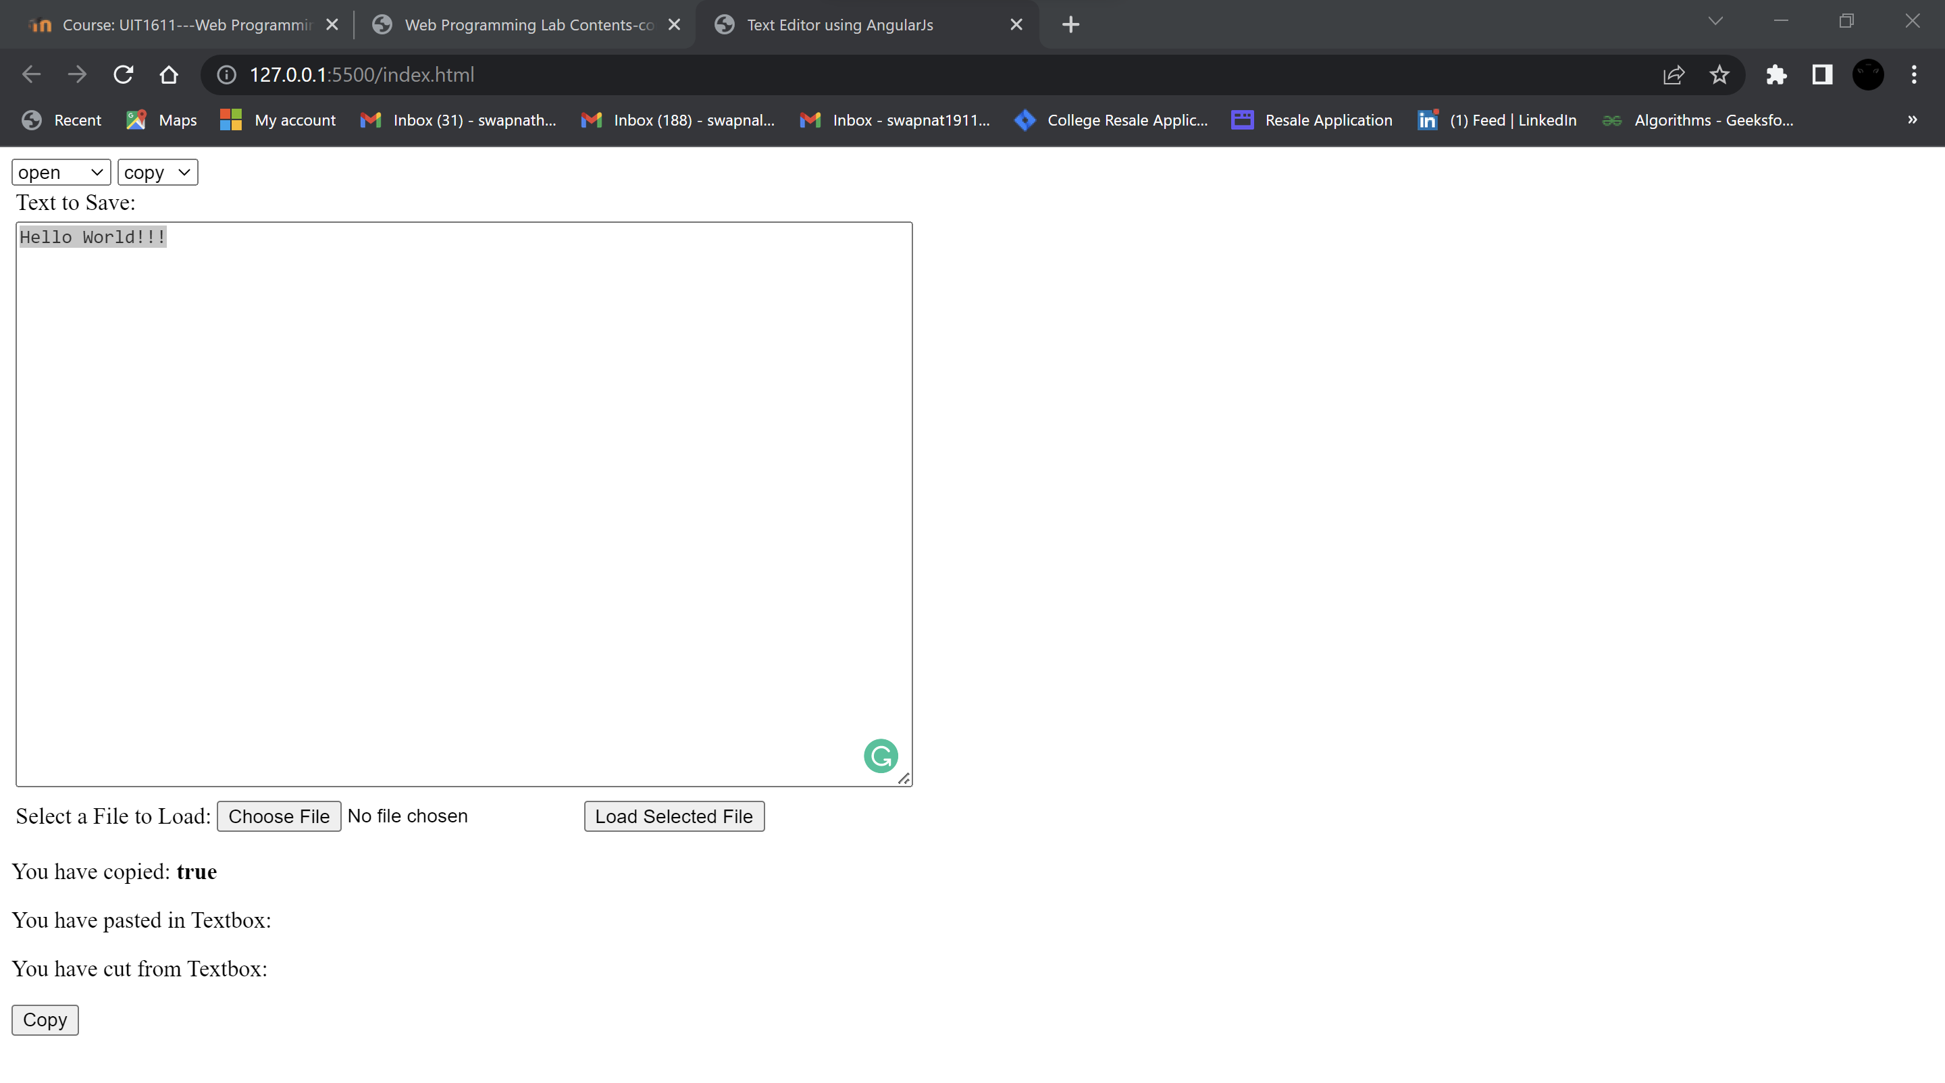

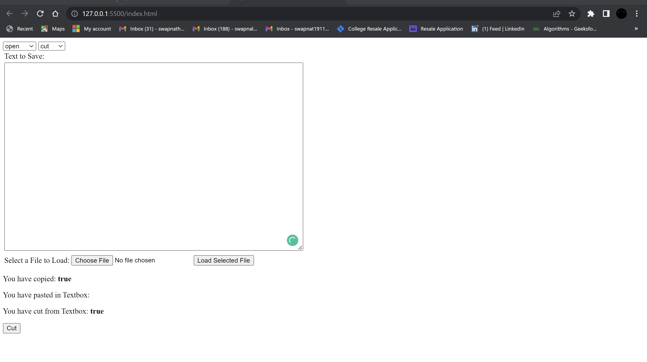

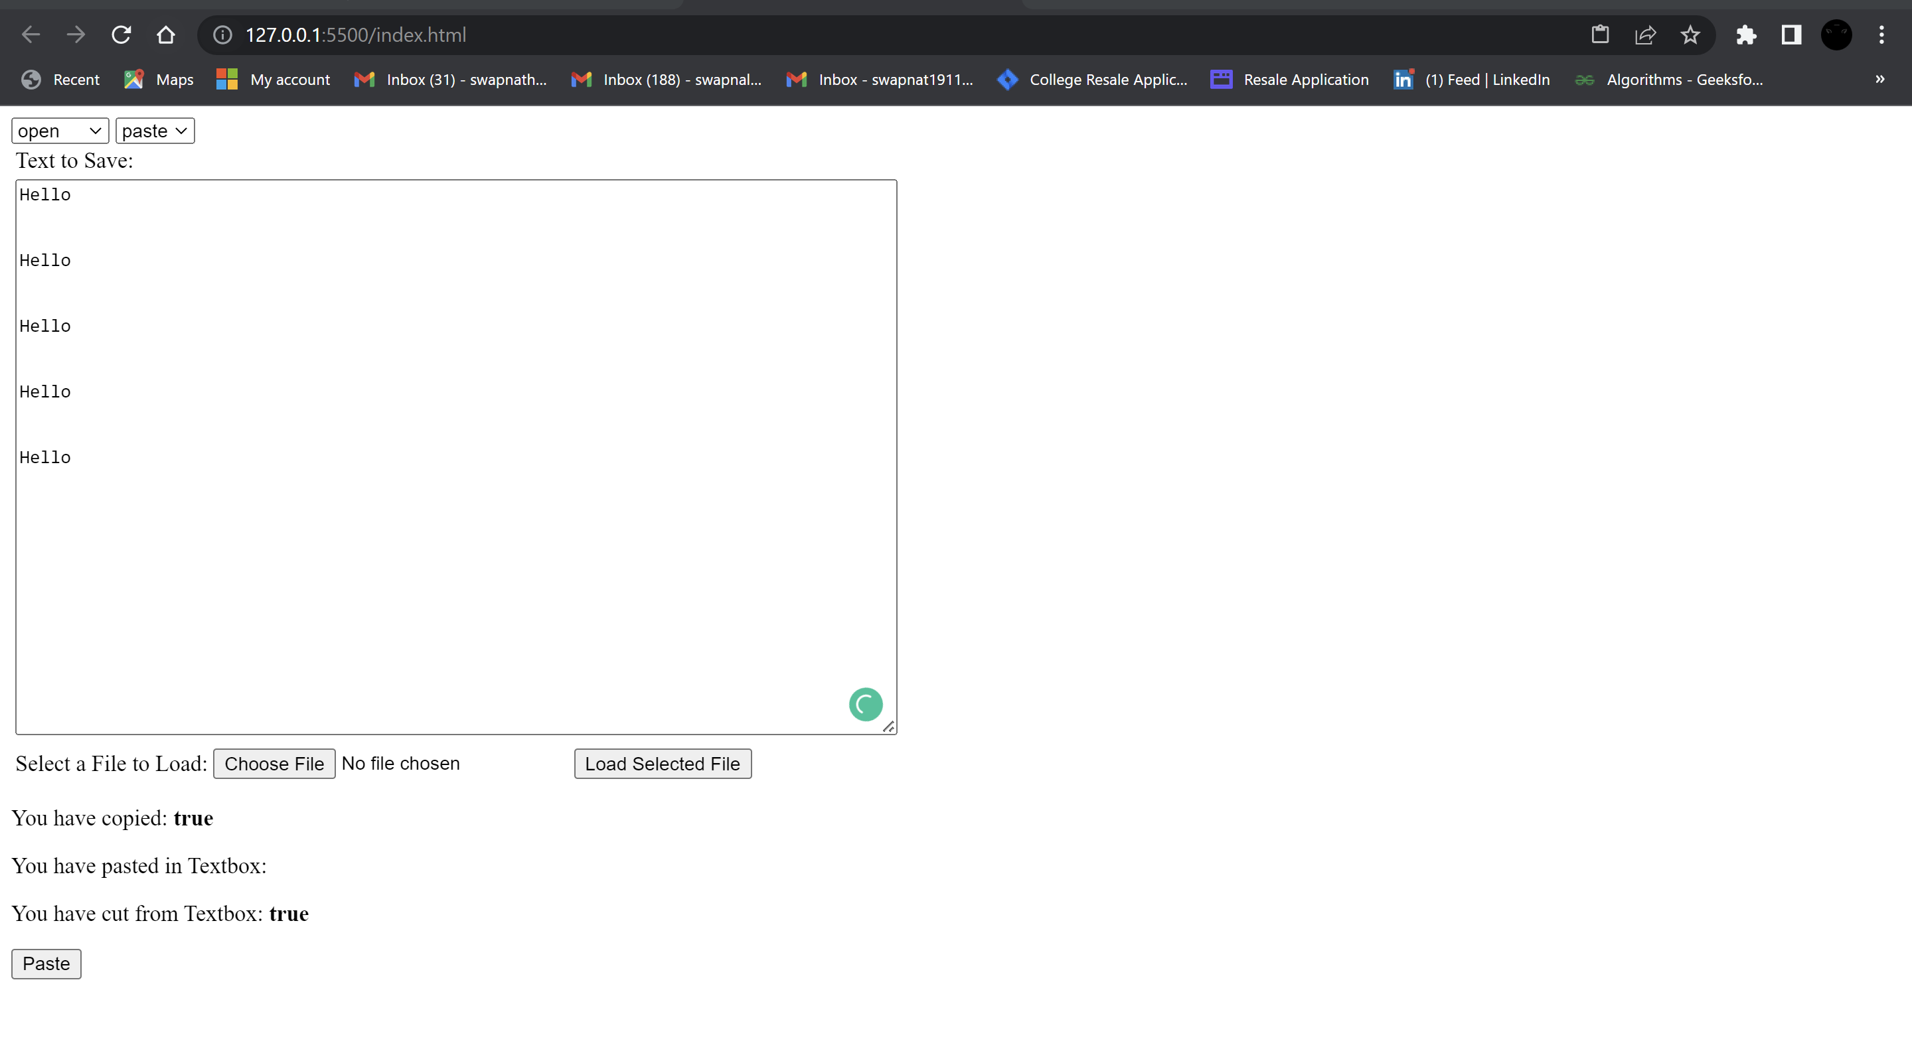

**Result:**

Thus, Text editor is successfully implemented using angular JS.

# **MEAN stack application**

**Exercise-9**

**Date:07-06-2022**

**Aim:**

To create a simple web application using MEAN stack.

**Procedure:**

* Set up the components of MEAN stack- MongoDB, ExpressJS, AngularJS, NodeJS •
* The json file is interesting because this file has all the dependencies and developmentonly dependencies of the project. Some MongoDB dependencies are added there later.
* Get the files for configuring the Typescript compilation.
* Get the json file that is for the Angular CLI.
* The e2e folder is for end-to-end testing and node_modules stores all the dependencies that are listed in json.
* In the src folder, the angular application lives in. More config files and an app is obtained.
* In-app folder, the meet of our Angular application is written.

**Code:**

**Register.html**

<div ng-app="myApp" ng-controller="userController">

<center>

<h1><b>BookThrift</b></h1>

<form ng-app="myApp" name="myForm" class="register" novalidate ng-submit="register.regUser(regData)">

<p>Username:<br>

<input type="text" name="user" ng-model="register.regData.username" ng-pattern="re1" required><br>

<span style="color:red" ng-show="myForm.user.$dirty && myForm.user.$invalid">

<span ng-show="myForm.user.$error.required">Username is required.</span>

</span>

</p>

<p>Email:<br>

<input type="email" name="email" ng-model="register.regData.email" ng-pattern="re"required><br>

<span style="color:red" ng-show="myForm.email.$dirty && myForm.email.$invalid">

<span ng-show="myForm.email.$error.required">Email is required.</span>

<span ng-show="myForm.email.$error.email">Invalid email address.</span>

</span>

</p>

<p>Password:<br>

<input type="password" name="pass" ng-model="register.regData.password" required><br>

<span style="color:red" ng-show="myForm.pass.$dirty && myForm.pass.$invalid">

<span ng-show="myForm.pass.$error.required">

<small ng-show="myForm.pass.$error.required">Password is required.</small>

<small ng-show="myForm.pass.$error.password">Invalid password.</small>

</span>

</span>

</p>

<p>Confirm password:<br>

<input type="password" name="con_pass" ng-model="register.regData.confirm_password" ng-keyup="compare(con_pass)" required><br>

<span style="color:red" ng-show="myForm.con_pass.$dirty && myForm.con_pass.$invalid">

<span ng-show="myForm.con_pass.$error.required">

<small ng-show="myForm.con_pass.$error.required">Confirm password is required.</small>

<small ng-show="myForm.con_pass.$error.password">Invalid password.</small>

</span>

</span>

</p>

<p id="demo">

<button type="submit" class="btn"

ng-disabled="myForm.user.$dirty && myForm.user.$invalid || myForm.email.$dirty && myForm.email.$invalid">Register</button>

</p>

<p><i>Already have an account?</i></p>

<a href="#!/login" id="reg"><e>Login!</e></a>

</form>

<br>

<div ng-show="register.success_message">

<div class="success">{{register.success_message}}</div>

</div><br>

<div ng-show="register.error_message">

<div class="error">{{register.error_message}}</div>

</div>

</center>

</div><br>

**Login.html**

<div ng-app="myApp" ng-controller="loginCtrl">

<center>

<h1><b>BookThrift</b></h1>

<form name="myForm" class="register" novalidate ng-submit="login.logUser(logData)" >

<p>Email:<br>

<input type="email" name="email" ng-model="login.logData.email" ng-pattern="re"required><br>

<span style="color:red" ng-show="myForm.email.$dirty && myForm.email.$invalid">

<span ng-show="myForm.email.$error.required">Email is required.</span>

<span ng-show="myForm.email.$error.email">Invalid email address.</span>

</span>

</p>

<p>Password:<br>

<input type="password" name="pass" ng-model="login.logData.password" ng-pattern="/^(?=.[A-Za-z])(?=.\d)(?=.[$@$!%#?&])[A-Za-z\d$@$!%*#?&]{8,}$/" required><br>

<span style="color:red" ng-show="myForm.pass.$dirty && myForm.pass.$invalid">

<span ng-show="myForm.pass.$error.required">

<small ng-show="myForm.pass.$error.required">Password is required.</small>

<small ng-show="myForm.pass.$error.password">Invalid password.</small>

</span>

</span>

</p>

<p id="demo">

<button type="submit" class="btn"

ng-disabled="myForm.email.$dirty && myForm.email.$invalid" >Login</button><br><br>

</p>

<p><i>New to BookThrift?</i></p>

<a href="#!/register" id="reg"><e>CREATE YOUR ACCOUNT!</e></a>

</form>

<br>

<div ng-show="login.success_message">

<div class="success">{{login.success_message}}</div>

</div><br>

<div ng-show="login.error_message">

<div class="error">{{login.error_message}}</div>

</div>

</center>

</div><br>

**App.js**

var myApp = angular.module('myApp',['ngRoute','ngAnimate']);

myApp.config(function($routeProvider){

$routeProvider

.when("/",{

templateUrl: "home.html"

})

.when("/home",{

templateUrl: "home.html"

})

.when("/fiction",{

templateUrl: "fiction.html"

})

.when("/crime",{

templateUrl: "crime.html"

})

.when("/romance",{

templateUrl: "romance.html"

})

.when("/classics",{

templateUrl: "classics.html"

})

.when("/nonfiction",{

templateUrl: "nonfiction.html"

})

.when("/youngadult",{

templateUrl: "youngadult.html"

})

.when("/account",{

templateUrl: "account.html"

})

.when("/cart",{

templateUrl: "cart.html"

})

.when("/login",{

templateUrl: "login.html",

controller: "loginCtrl",

controllerAs: "login"

})

.when("/order",{

templateUrl: "order.html"

})

.when("/rateus",{

templateUrl: "rateus.html"

})

.when("/register",{

templateUrl: "register.html",

controller: "userController",

controllerAs: "register"

})

.when("/sell",{

templateUrl: "sell.html"

})

});

myApp.component("hello",{

template:

`<center>

<h2>Personal Info</h2>

<p>User Name</p>

<input type="text" ng-model="username"><br>

<p>Welcome <span ng-bind="username"></span> !!</p>

<p>Email</p>

<input type="email" name="email" id="email"/>

<p>Contact number</p>

<input type="text" name="number" id="number"/>

<p>Gender</p>

<select value="select">

<option>Select</option>

<option>Female</option>

<option>Male</option>

<option>other</option>

</select>

<p>Date of Birth</p>

<input type="date" name="dob" id="dob"/><br><br>

<button value="Edit">edit</button>

<button value="Save">Save</button>

</div>

</center>`

});

myApp.controller("searchController_classic",function($scope){

$scope.carts=[];

$scope.classics=[

{book_image:"images/classics_1.png",book_name:"The Great Gatsby",author:"F Scott Fitzgerald",price:"300.00"},

{book_image:"images/classics_2.jpg",book_name:"Pride and Prejudice",author:"Jane Austin",price:"350.00"},

{book_image:"images/classics_3.jpg",book_name:"The Wealth of Nations",author:"Adam Smith",price:"395.00"},

{book_image:"images/classics_4.jpg",book_name:"The Divine Comedy",author:"Dante",price:"325.00"},

{book_image:"images/classics_5.jpg",book_name:"A Small Fortune",author:"Rosie Dastgir",price:"195.00"},

{book_image:"images/classics_6.jpg",book_name:"The Goldfinch",author:"Donna Tartt",price:"225.00"},

{book_image:"images/classics_7.jpg",book_name:"A Teaspoon of Earth and Sea",author:"Dina Nayeri",price:"250.00"},

{book_image:"images/classics_8.jpg",book_name:"The Little Prince",author:"Antoine de Saint-Exupéry",price:"195.00"},

];

$scope.add_cart = function(c){

if(c){

$scope.carts.push({book_image:c.book_image, book_name:c.book_name, author:c.author,price:c.price});

}

}

$scope.total=0;

$scope.setTotals = function(cart){

if(cart){

var a=Number(cart.price || 0);

$scope.total += a;

}

}

$scope.remove_cart = function(cart){

if(cart){

$scope.carts.splice($scope.carts.indexOf(cart), 1);

$scope.total -= cart.price;

}

}

});

myApp.controller("searchController_crime",function($scope){

$scope.carts=[];

$scope.crime=[

{book_image:"images/crime_1.jpg",book_name:"The Murder of Roger Ackroyd",author:"Agatha Christie",price:"350.00"},

{book_image:"images/crime_2.jpg",book_name:"The girl in the room 105",author:"Jane Chetan Bhagat",price:"250.00"},

{book_image:"images/crime_3.jpg",book_name:"The Silent Patient",author:"Alex Michaelides",price:"395.00"},

{book_image:"images/crime_4.jpg",book_name:"Behind her eyes",author:"Sarah Pinborough",price:"125.00"},

{book_image:"images/crime_5.jpg",book_name:"Deadly still water",author:"Roger Stelljes",price:"195.00"},

{book_image:"images/crime_6.png",book_name:"The Dead Don't Talk",author:"Sumit Ghosal",price:"295.00"},

{book_image:"images/crime_7.jpg",book_name:"The Invited",author:"Jennifer McMahon",price:"150.00"},

{book_image:"images/crime_8.jpg",book_name:"Then she was gone",author:"Lisa Jewell",price:"195.00"},

];

$scope.add_cart = function(cr){

if(cr){

$scope.carts.push({book_image:cr.book_image, book_name:cr.book_name, author:cr.author,price:cr.price});

}

}

$scope.total=0;

$scope.setTotals = function(cart){

if(cart){

var a=Number(cart.price || 0);

$scope.total += a;

}

}

$scope.remove_cart = function(cart){

if(cart){

$scope.carts.splice($scope.carts.indexOf(cart), 1);

$scope.total -= cart.price;

}

}

});

myApp.controller("searchController_fiction",function($scope){

$scope.carts=[];

$scope.fiction=[

{book_image:"images/fic_1.jpg",book_name:"The Palace of Illusions",author:"Chitra Banerjee",price:"350.00"},

{book_image:"images/fic_2.jpg",book_name:"The forest of enchantments",author:"Chitra Banerjee",price:"250.00"},

{book_image:"images/fic_3.jpg",book_name:"The fault in our stars",author:"John Green",price:"295.00"},

{book_image:"images/fic_4.jpg",book_name:"Roald Dahl",author:"Quentin Blake",price:"150.00"},

{book_image:"images/fic_5.jfif",book_name:"The Vines",author:"Shelley Nolden",price:"295.00"},

{book_image:"images/fic_6.jpg",book_name:"All the light we cannot see",author:"Anthony Doe",price:"195.00"},

{book_image:"images/fic_7.jfif",book_name:"The Diamond Eye",author:"Kate Quinn",price:"200.00"},

{book_image:"images/fic_8.jpg",book_name:"Blue Skies",author:"Anne Bustard",price:"195.00"},

];

$scope.add_cart = function(f){

if(f){

$scope.carts.push({book_image:f.book_image, book_name:f.book_name, author:f.author,price:f.price});

}

}

$scope.total=0;

$scope.setTotals = function(cart){

if(cart){

var a=Number(cart.price || 0);

$scope.total += a;

}

}

$scope.remove_cart = function(cart){

if(cart){

$scope.carts.splice($scope.carts.indexOf(cart), 1);

$scope.total -= cart.price;

}

}

});

myApp.controller("searchController_nonfiction",function($scope){

$scope.carts=[];

$scope.nonfiction=[

{book_image:"images/nf_1.jpg",book_name:"Sapiens - A Brief history of humankind",author:"Yuval Noah Harari",price:"350.00"},

{book_image:"images/nf_2.jfif",book_name:"Atomic habits",author:"James Clear",price:"250.00"},

{book_image:"images/nf_3.jpg",book_name:"Into the wild",author:"Jon Krakauer",price:"395.00"},

{book_image:"images/nf_4.jpg",book_name:"I am malala",author:"Malala Yousafzai",price:"225.00"},

{book_image:"images/nf_5.jpg",book_name:"How to do nothing",author:"Jenny Odell",price:"145.00"},

{book_image:"images/nf_6.jpg",book_name:"The diary of a young girl",author:"Anne Frank",price:"175.00"},

{book_image:"images/nf_7.jpg",book_name:"How to win friends and influence people",author:"Dale Carnegie",price:"215.00"},

{book_image:"images/nf_8.jpg",book_name:"In cold blood",author:"Truman Capote",price:"165.00"},

];

$scope.add_cart = function(no){

if(no){

$scope.carts.push({book_image:no.book_image, book_name:no.book_name, author:no.author,price:no.price});

}

}

$scope.total=0;

$scope.setTotals = function(cart){

if(cart){

var a=Number(cart.price || 0);

$scope.total += a;

}

}

$scope.remove_cart = function(cart){

if(cart){

$scope.carts.splice($scope.carts.indexOf(cart), 1);

$scope.total -= cart.price;

}

}

});

myApp.controller("searchController_romance",function($scope){

$scope.carts=[];

$scope.romance=[

{book_image:"images/romance_1.jpg",book_name:"Fly away",author:"kristin Hannah",price:"350.00"},

{book_image:"images/romace_2.jpg",book_name:"The Notebook",author:"Nicholas Sparks",price:"240.00"},

{book_image:"images/romance_3.jpg",book_name:"Paris is Always a Good Idea",author:"Jenn McKinlay",price:"295.00"},

{book_image:"images/romance_4.jpg",book_name:"It ends with us",author:"Colleen Hoover",price:"225.00"},

{book_image:"images/romance_5.jpg",book_name:"November 9",author:"Colleen Hoover",price:"195.00"},

{book_image:"images/romance_6.jpg",book_name:"A Touch of Eternity",author:"Durjoy Datta",price:"295.00"},

{book_image:"images/romance_7.jpg",book_name:"All this time",author:"Mikki Daughtry and Rachael Lippincott",price:"150.00"},

{book_image:"images/romance_8.jpg",book_name:"She fell in love with her best friend",author:"Sharad Raj C",price:"195.00"},

];

$scope.add_cart = function(ro){

if(ro){

$scope.carts.push({book_image:ro.book_image, book_name:ro.book_name, author:ro.author,price:ro.price});

}

}

$scope.total=0;

$scope.setTotals = function(cart){

if(cart){

var a=Number(cart.price || 0);

$scope.total += a;

}

}

$scope.remove_cart = function(cart){

if(cart){

$scope.carts.splice($scope.carts.indexOf(cart), 1);

$scope.total -= cart.price;

}

}

});

myApp.controller("searchController_youngadult",function($scope){

$scope.carts=[];

$scope.youngadult=[

{book_image:"images/ya_1.jpg",book_name:"Gallant",author:"V.E. Schwab",price:"300.00"},

{book_image:"images/ya_2.jpg",book_name:"A magic steeped in poison",author:"Judy I. Lin",price:"350.00"},

{book_image:"images/ya_3.jpg",book_name:"Blood Scion",author:"Deborah Falaye",price:"395.00"},

{book_image:"images/ya_4.jpg",book_name:"Edgewood",author:"Kristen ciccarelli",price:"325.00"},

{book_image:"images/ya_5.jpg",book_name:"All that's left in the world",author:"Erik J. Brown",price:"195.00"},

{book_image:"images/ya_6.jpg",book_name:"The Lost Dreamer",author:"Lizz Huerta",price:"295.00"},

{book_image:"images/ya_7.jpg",book_name:"A forger of roses",author:"Jessica S. Olson",price:"155.00"},

{book_image:"images/ya_8.jpg",book_name:"The book of living secrets",author:"Madeleine Roux",price:"195.00"},

];

$scope.add_cart = function(y){

if(y){

$scope.carts.push({book_image:y.book_image, book_name:y.book_name, author:y.author,price:y.price});

}

}

$scope.total=0;

$scope.setTotals = function(cart){

if(cart){

var a=Number(cart.price || 0);

$scope.total += a;

}

}

$scope.remove_cart = function(cart){

if(cart){

$scope.carts.splice($scope.carts.indexOf(cart), 1);

$scope.total -= cart.price;

}

}

});

myApp.controller("searchController_home",function($scope){

$scope.carts=[];

$scope.home=[

{book_image:"images/bs_1.jpg",book_name:"The Hunger Games",author:"Suzanne Collins",price:"1300.00"},

{book_image:"images/bs_2.jfif",book_name:"The Shiva Trilogy",author:"Amish Tripati",price:"950.00"},

{book_image:"images/bs_3.jfif",book_name:"Harry Potter",author:"Harry Potter",price:"1395.00"},

{book_image:"images/bs_4.jpg",book_name:"Percy Jackson",author:"Rick Riordan",price:"1825.00"},

{book_image:"images/bs_5.jpg",book_name:"The Ramachandra Series",author:"Amish Tripati",price:"1595.00"},

{book_image:"images/bs_6.jpg",book_name:"The Dan Brown Collection",author:"Dan Brown",price:"995.00"},

{book_image:"images/bs_7.jpg",book_name:"Roald Dahl Collection",author:"Roald Dahl",price:"1055.00"},

{book_image:"images/bs_8.jpg",book_name:"Diary of a wimpy kid",author:"Jeff Kinney",price:"1095.00"},

{book_image:"images/classics_1.png",book_name:"The Great Gatsby",author:"F Scott Fitzgerald",price:"300.00"},

{book_image:"images/classics_2.jpg",book_name:"Pride and Prejudice",author:"Jane Austin",price:"350.00"},

{book_image:"images/classics_3.jpg",book_name:"The Wealth of Nations",author:"Adam Smith",price:"395.00"},

{book_image:"images/classics_4.jpg",book_name:"The Divine Comedy",author:"Dante",price:"325.00"},

{book_image:"images/classics_5.jpg",book_name:"A Small Fortune",author:"Rosie Dastgir",price:"195.00"},

{book_image:"images/classics_6.jpg",book_name:"The Goldfinch",author:"Donna Tartt",price:"225.00"},

{book_image:"images/classics_7.jpg",book_name:"A Teaspoon of Earth and Sea",author:"Dina Nayeri",price:"250.00"},

{book_image:"images/classics_8.jpg",book_name:"The Little Prince",author:"Antoine de Saint-Exupéry",price:"195.00"},

{book_image:"images/crime_1.jpg",book_name:"The Murder of Roger Ackroyd",author:"Agatha Christie",price:"350.00"},

{book_image:"images/crime_2.jpg",book_name:"The girl in the room 105",author:"Jane Chetan Bhagat",price:"250.00"},

{book_image:"images/crime_3.jpg",book_name:"The Silent Patient",author:"Alex Michaelides",price:"395.00"},

{book_image:"images/crime_4.jpg",book_name:"Behind her eyes",author:"Sarah Pinborough",price:"125.00"},

{book_image:"images/crime_5.jpg",book_name:"Deadly still water",author:"Roger Stelljes",price:"195.00"},

{book_image:"images/crime_6.png",book_name:"The Dead Don't Talk",author:"Sumit Ghosal",price:"295.00"},

{book_image:"images/crime_7.jpg",book_name:"The Invited",author:"Jennifer McMahon",price:"150.00"},

{book_image:"images/crime_8.jpg",book_name:"Then she was gone",author:"Lisa Jewell",price:"195.00"},

{book_image:"images/fic_1.jpg",book_name:"The Palace of Illusions",author:"Chitra Banerjee",price:"350.00"},

{book_image:"images/fic_2.jpg",book_name:"The forest of enchantments",author:"Chitra Banerjee",price:"250.00"},

{book_image:"images/fic_3.jpg",book_name:"The fault in our stars",author:"John Green",price:"295.00"},

{book_image:"images/fic_4.jpg",book_name:"Roald Dahl",author:"Quentin Blake",price:"150.00"},

{book_image:"images/fic_5.jfif",book_name:"The Vines",author:"Shelley Nolden",price:"295.00"},

{book_image:"images/fic_6.jpg",book_name:"All the light we cannot see",author:"Anthony Doe",price:"195.00"},

{book_image:"images/fic_7.jfif",book_name:"The Diamond Eye",author:"Kate Quinn",price:"200.00"},

{book_image:"images/fic_8.jpg",book_name:"Blue Skies",author:"Anne Bustard",price:"195.00"},

{book_image:"images/nf_1.jpg",book_name:"Sapiens - A Brief history of humankind",author:"Yuval Noah Harari",price:"350.00"},

{book_image:"images/nf_2.jfif",book_name:"Atomic habits",author:"James Clear",price:"250.00"},

{book_image:"images/nf_3.jpg",book_name:"Into the wild",author:"Jon Krakauer",price:"395.00"},

{book_image:"images/nf_4.jpg",book_name:"I am malala",author:"Malala Yousafzai",price:"225.00"},

{book_image:"images/nf_5.jpg",book_name:"How to do nothing",author:"Jenny Odell",price:"145.00"},

{book_image:"images/nf_6.jpg",book_name:"The diary of a young girl",author:"Anne Frank",price:"175.00"},

{book_image:"images/nf_7.jpg",book_name:"How to win friends and influence people",author:"Dale Carnegie",price:"215.00"},

{book_image:"images/nf_8.jpg",book_name:"In cold blood",author:"Truman Capote",price:"165.00"},

{book_image:"images/romance_1.jpg",book_name:"Fly away",author:"kristin Hannah",price:"350.00"},

{book_image:"images/romace_2.jpg",book_name:"The Notebook",author:"Nicholas Sparks",price:"240.00"},

{book_image:"images/romance_3.jpg",book_name:"Paris is Always a Good Idea",author:"Jenn McKinlay",price:"295.00"},

{book_image:"images/romance_4.jpg",book_name:"It ends with us",author:"Colleen Hoover",price:"225.00"},

{book_image:"images/romance_5.jpg",book_name:"November 9",author:"Colleen Hoover",price:"195.00"},

{book_image:"images/romance_6.jpg",book_name:"A Touch of Eternity",author:"Durjoy Datta",price:"295.00"},

{book_image:"images/romance_7.jpg",book_name:"All this time",author:"Mikki Daughtry and Rachael Lippincott",price:"150.00"},

{book_image:"images/romance_8.jpg",book_name:"She fell in love with her best friend",author:"Sharad Raj C",price:"195.00"},

{book_image:"images/ya_1.jpg",book_name:"Gallant",author:"V.E. Schwab",price:"300.00"},

{book_image:"images/ya_2.jpg",book_name:"A magic steeped in poison",author:"Judy I. Lin",price:"350.00"},

{book_image:"images/ya_3.jpg",book_name:"Blood Scion",author:"Deborah Falaye",price:"395.00"},

{book_image:"images/ya_4.jpg",book_name:"Edgewood",author:"Kristen ciccarelli",price:"325.00"},

{book_image:"images/ya_5.jpg",book_name:"All that's left in the world",author:"Erik J. Brown",price:"195.00"},

{book_image:"images/ya_6.jpg",book_name:"The Lost Dreamer",author:"Lizz Huerta",price:"295.00"},

{book_image:"images/ya_7.jpg",book_name:"A forger of roses",author:"Jessica S. Olson",price:"155.00"},

{book_image:"images/ya_8.jpg",book_name:"The book of living secrets",author:"Madeleine Roux",price:"195.00"},

];

$scope.add_cart = function(y){

if(y){

$scope.carts.push({book_image:y.book_image, book_name:y.book_name, author:y.author,price:y.price});

}

}

$scope.total=0;

$scope.setTotals = function(cart){

if(cart){

var a=Number(cart.price || 0);

$scope.total += a;

}

}

$scope.remove_cart = function(cart){

if(cart){

$scope.carts.splice($scope.carts.indexOf(cart), 1);

$scope.total -= cart.price;

}

}

});

myApp.service("msg",function(){

this.serv_fun=function(){

return "Thank you! Will get back to you soon.";

}

})

myApp.controller("ctrl",function($scope,msg){

$scope.value=false;

$scope.myfun=function(){

$scope.value=true;

$scope.msg1=msg.serv_fun();}

})

function loadDoc() {

var xhttp = new XMLHttpRequest();

xhttp.onreadystatechange = function() {

if (this.readyState == 4 && this.status == 200) {

document.getElementById("demo").innerHTML = this.responseText;

}

};

xhttp.open("GET", "policy.txt", true);

xhttp.send();

}

myApp.controller("cartCtrl",function(){

});

myApp.controller("userController",function($http,$location,$timeout){

var app=this;

this.regUser=function(regData){

app.error_message=false;

$http.post('/api/users',this.regData).then(function(data){

console.log(data.data.success);

console.log(data.data.message);

if(data.data.success){

app.success_message=data.data.message+'...Redirecting';

$timeout(function(){

$location.path('#!/home')

},2000);

}else{

app.error_message=data.data.message;

}

});

}

});

// myApp.service('authServies',[])

// .factory('Auth',function($http){

// authFactory={};

// authFactory.login=function(logData){

// return $http.post('/api/authenticate',logData);

// }

// return authFactory;

// });

myApp.controller("loginCtrl",function($http,$location,$timeout){

var app=this;

this.logUser=function(logData){

$http.post('/api/authenticate',this.logData).then(function(data){

console.log(data.data.success);

console.log(data.data.message);

if(data.data.success){

app.success_message=data.data.message+'...Redirecting';

$timeout(function(){

$location.path('#!/home')

},2000);

}else{

app.error_message=data.data.message;

}

});

}

});

**Output:**

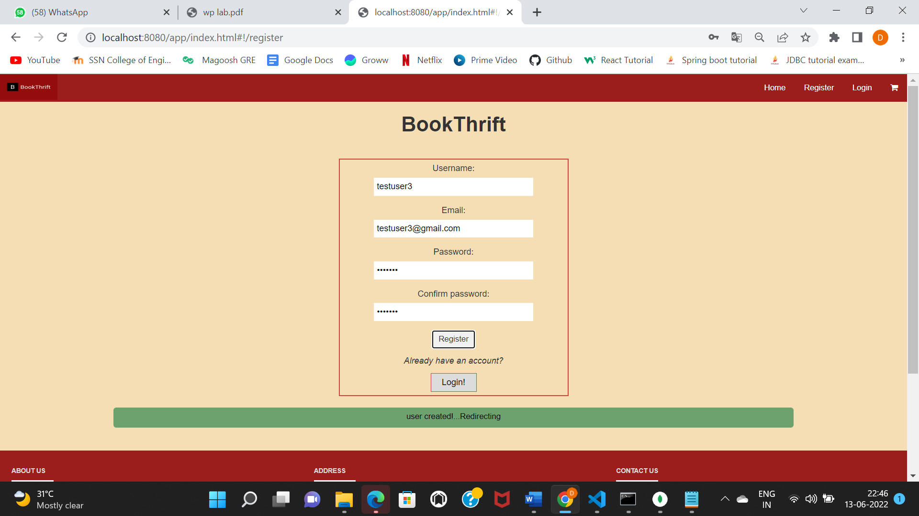

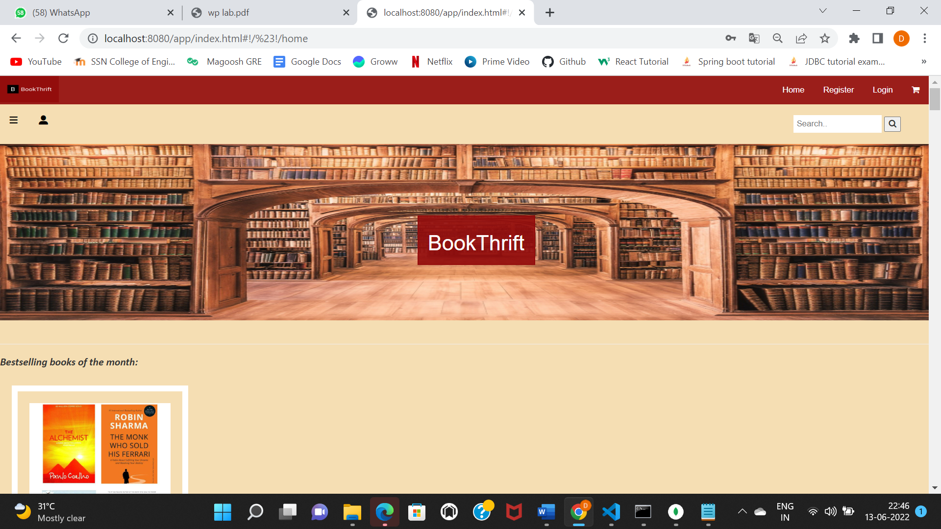

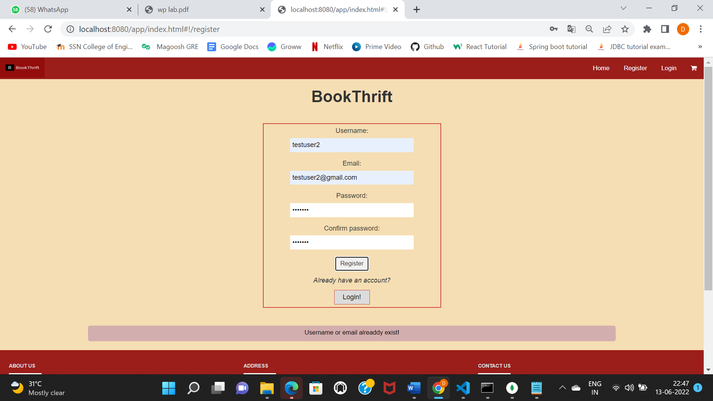

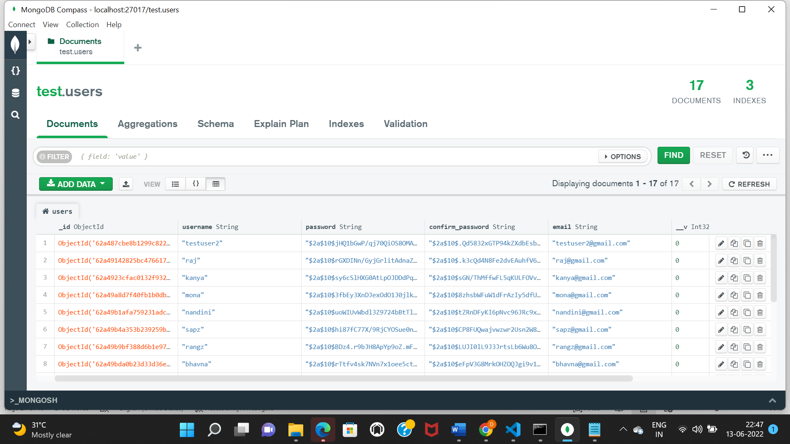

**Result:**

The above codes have been successfully executed to implement the MEAN stack.

# **Dynamic website using Node JS and Express**

**Exercise-10**

**Date:09-06-2022**

**Aim:**

To implement Dynamic website using NodeJS and Express.

**Procedure:**

* Create a new database in Mongodb using ‘use’ command - use mydb.
* Create a collection within the db using ‘db.createCollection(name, options) ‘ command, name is name of collection to be created. Options is a document and is used to specify configuration of collection.
* Install MongoDb driver in Node JS using ‘npm install mongodb’.
* Node Js uses this module manipulate MongoDB databases - var mongo = require('mongodb');
* Connect the mongo with node using MongoClient.connect(url, function(err, db) {} where
* url="mongodb://localhost:27017/";
* Insert into database using insertOne() which is an object containing the name(s) and value(s)
* of each field in the document you want to insert.
* Select data from a collection in MongoDB using the findOne() method which returns the first occurrence in the selection.
* Delete a record, or document we use the deleteOne() method. The first parameter of the deleteOne() method is a query object defining which document to delete.

**Code:**

**Switch_student.js**

var mongo = require('mongodb');

var MongoClient=require('mongodb').MongoClient;

var url="mongodb://localhost:27017/";

const prompt=require('prompt');

prompt.start();

console.log("1.Insert\n2.Update\n3.Delete\n4.Exit\n");

prompt.get(['choice'],function(err,result){

if(err) {

return onErr(Err);

}

switch(result.choice) {

case "1":

console.log("INSERT");

prompt.get(['Rno','Name','Age','Department'],function(err,result){

if(err) { return onErr(Err);}

console.log('Data from user :');

console.log('Rno - ' + result.Rno);

console.log('Name - ' + result.Name);

console.log('Age - ' + result.Age);

console.log('Department - ' + result.Department);

MongoClient.connect(url,{useUnifiedTopology: true},function(err,db) {

if(err) throw err;

var dbo=db.db("manisha");

var obj={Rno: result.Rno , Name:result.Name, Age: result.Age , Department :result.Department};

dbo.collection("student").insertOne(obj,function(err,res){

if(err) throw err;

console.log("Inserted 1 student document !! ");

db.close();

});

});

});

break;

case "2":

console.log("UPDATE");

prompt.get(['Rno','Name','Age','newDepartment'],function(err,result){

if(err) { return onErr(Err);}

MongoClient.connect(url,{useUnifiedTopology: true},function(err,db)

{

if(err) throw err;

var dbo=db.db("manisha");

var query={Rno:result.Rno};

var upd_val={$set: {Rno: result.Rno , Name:result.Name , Age: result.Age ,Department:result.newDepartment}};

dbo.collection("student").updateOne(query,upd_val,function(err,res){

if(err) throw err;

if(res.result=="0")

console.log("Key not found !! ");

else

{

console.log(res.result+ " student document Updated!! ");

db.close();

}

});

});

});

break;

case "3":

console.log("DELETE");

prompt.get(['Rno'],function(err,result){

if(err) {

return onErr(Err);}

MongoClient.connect(url,{useUnifiedTopology: true},function(err,db)

{

if(err) throw err;

var dbo=db.db("manisha");

var query={Rno:result.Rno};

dbo.collection("student").deleteOne(query,function(err,res){

if(err) throw err;

if(res.result=="0")

console.log("Key not found !! ");

else

{

console.log(res.result+ " student document Deleted!! ");

db.close();

}

});

});

});

break;

default:

console.log("EXIT")

}

});

function onErr(err){

console.log(err);

return 1;

}

**Output:**

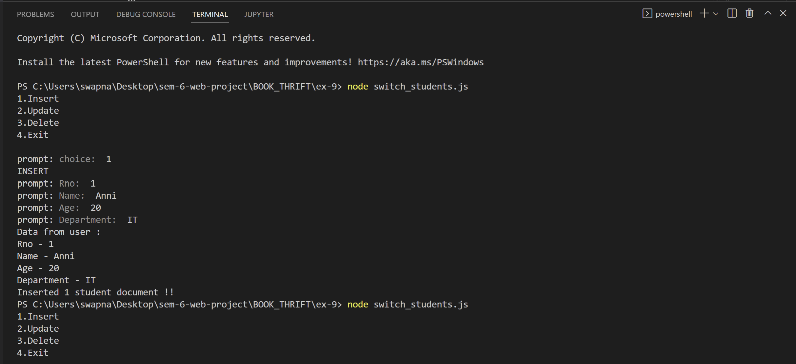

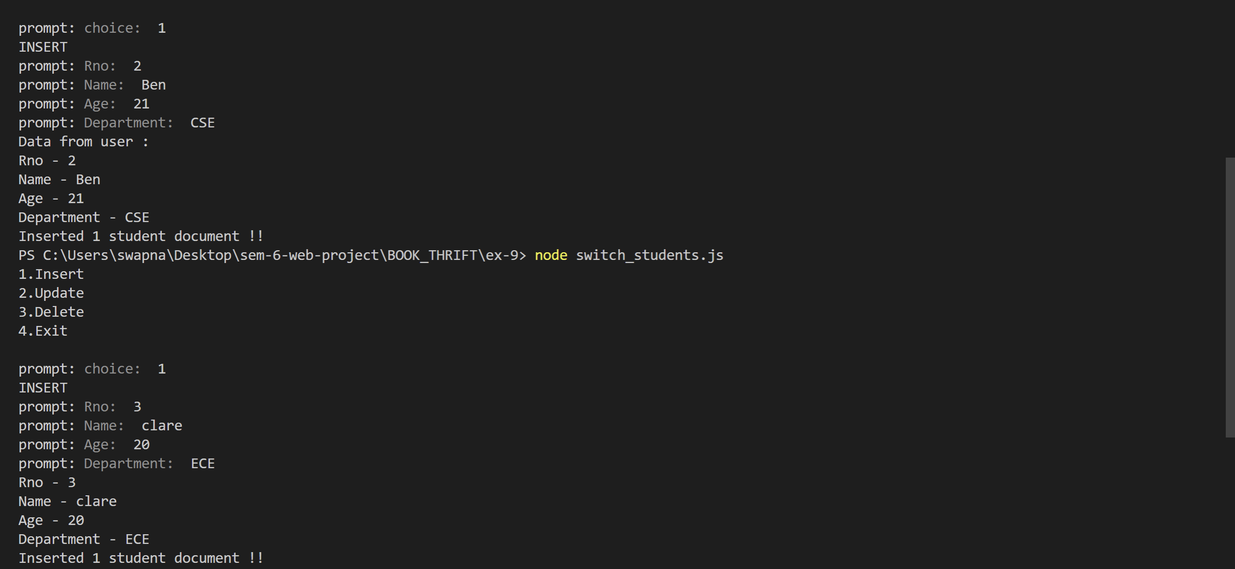

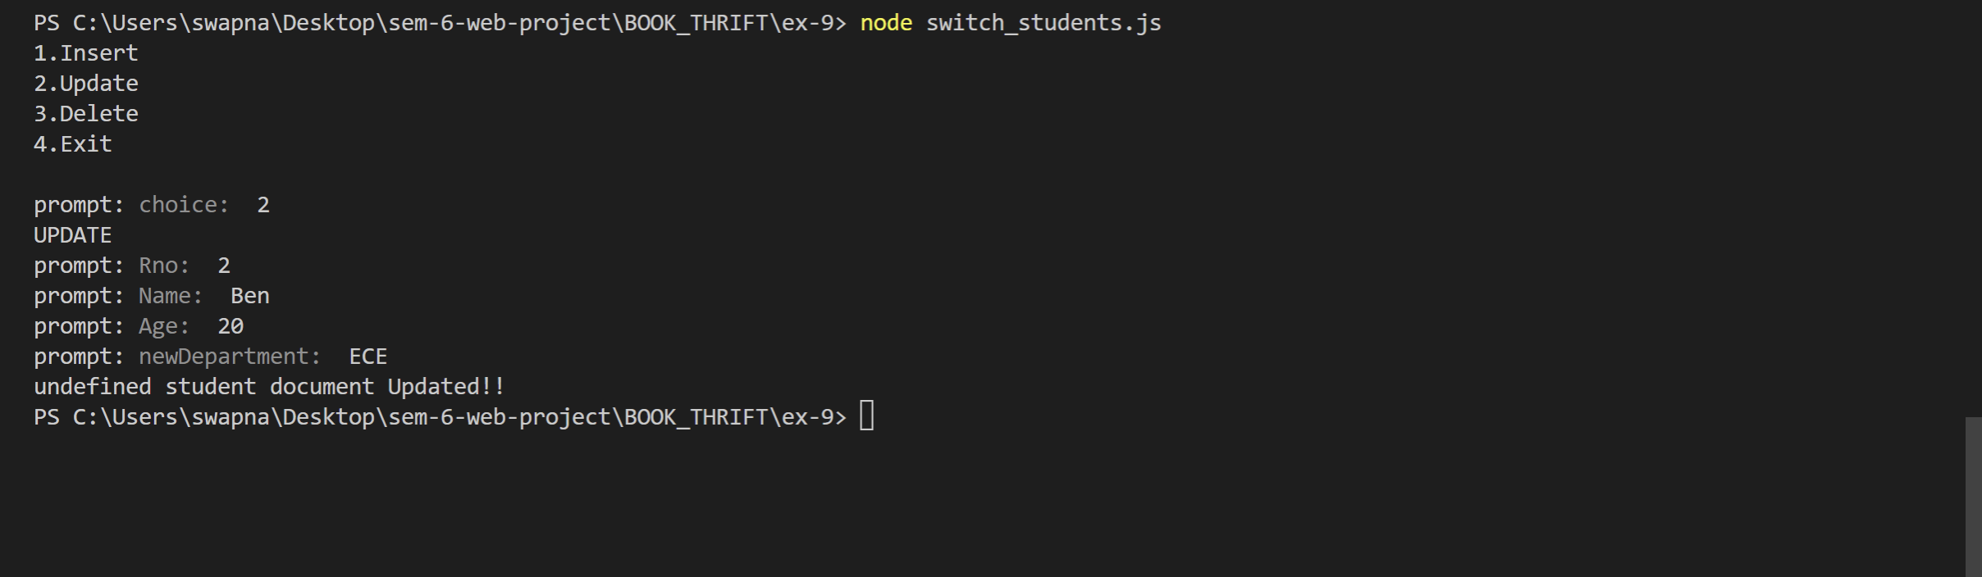

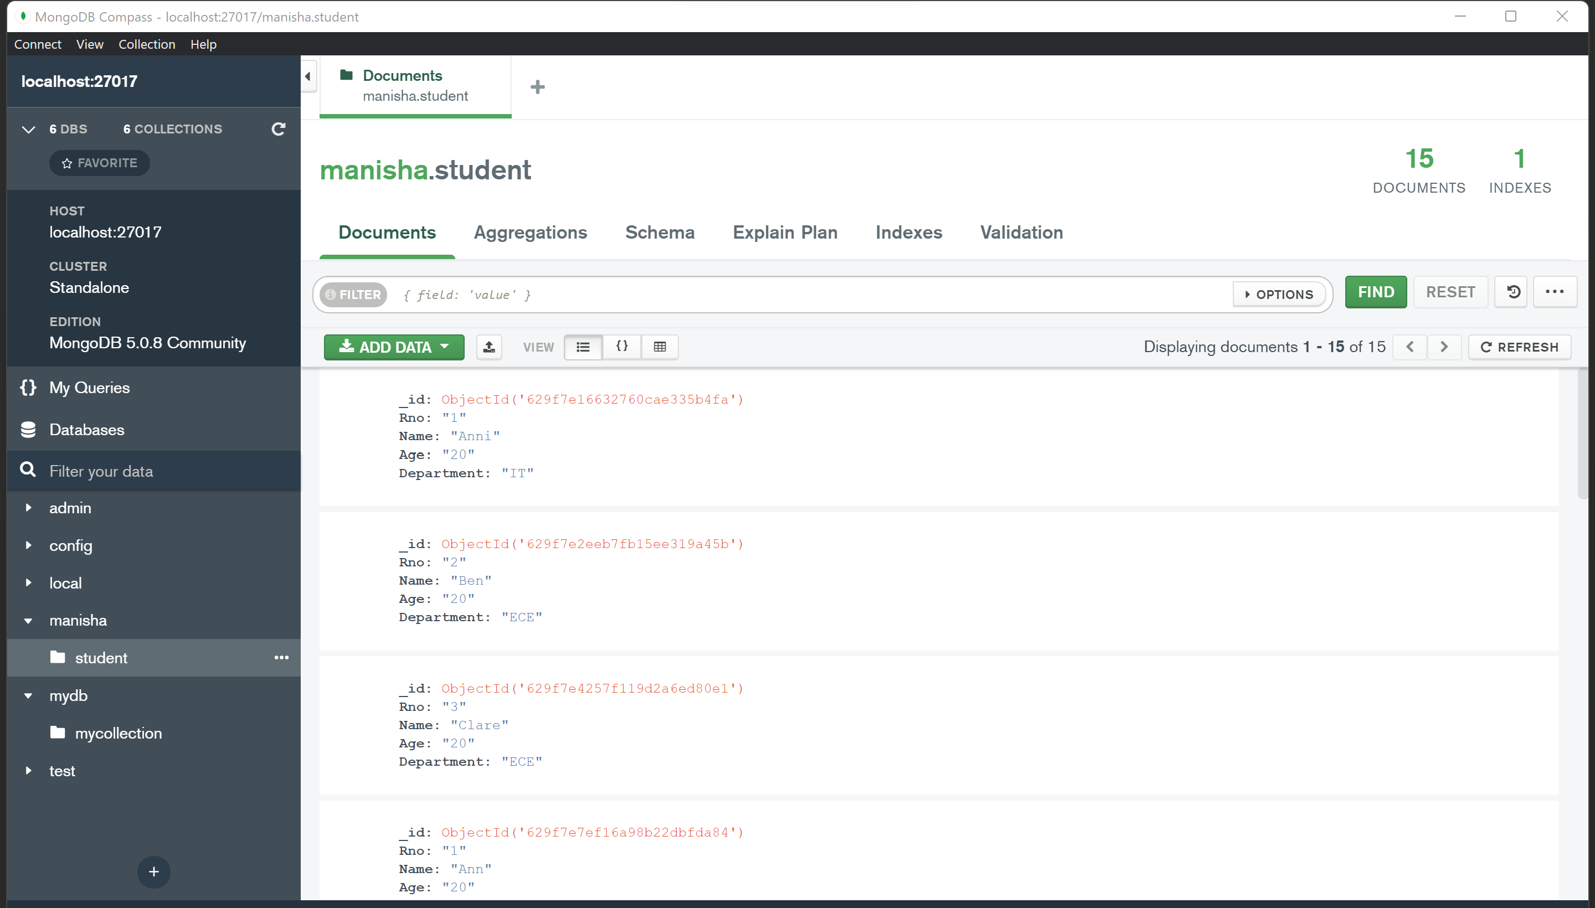

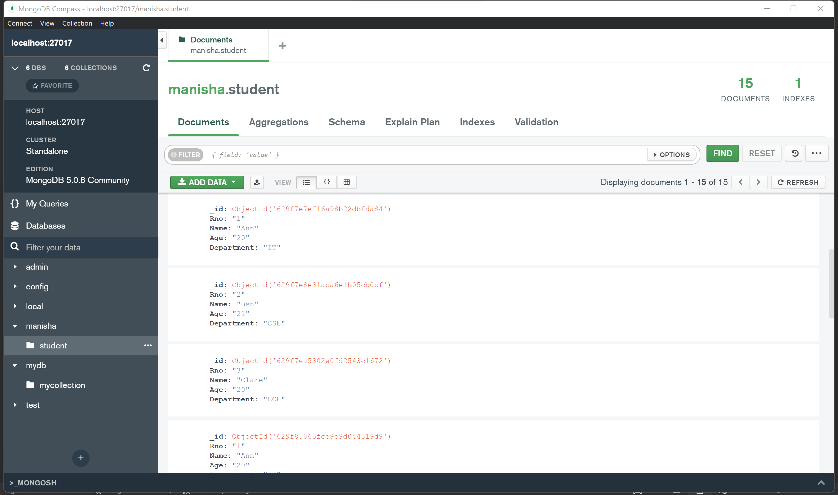

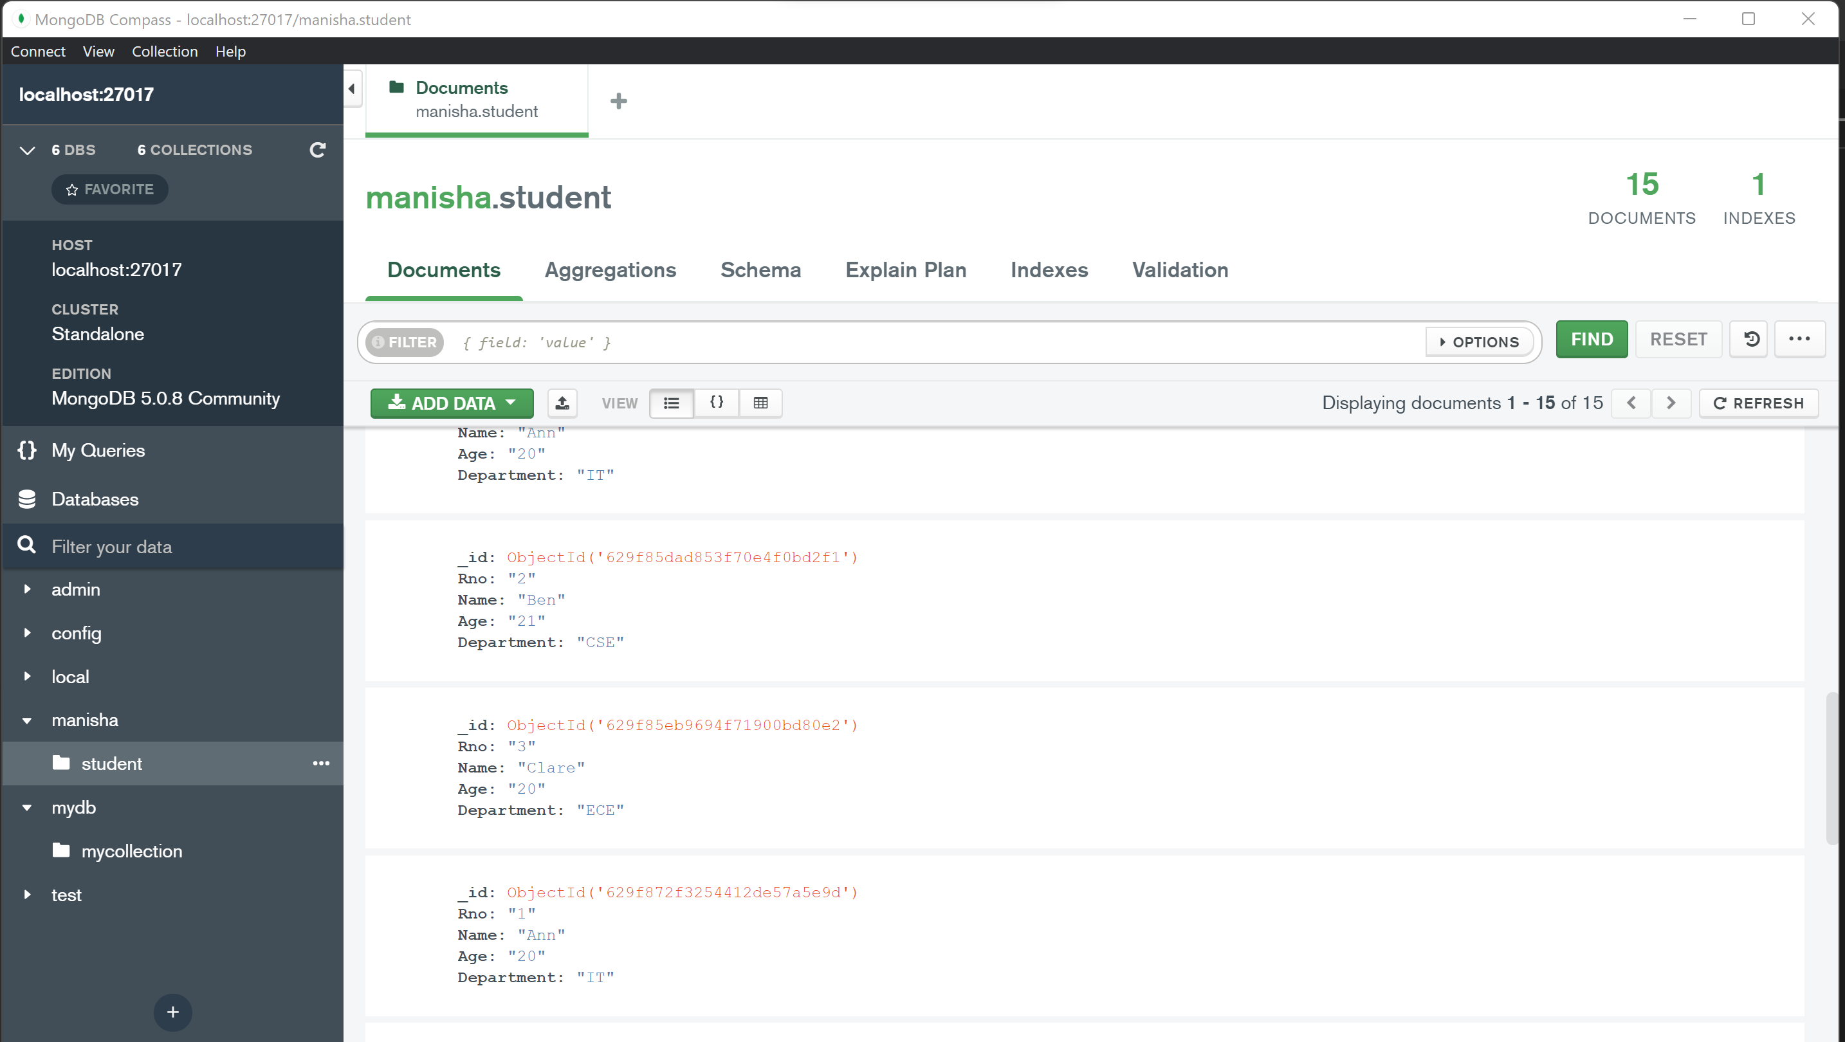

**Result:**

Thus , a dynamic website have been implemented successfully using Node JS and Express.

# 

# **Chat application with multiple rooms using Node and Express**

**Exercise-11**

**Date:11-06-2022**

**Aim:**

To implement a chat application with multiple rooms using Node and Express.

**Procedure:**

* To create a chat application, we use Socket.IO is a library which enables real-time, bidirectional and event-based communication between the browser and the server.
* It consists of: o a Node.js server o a Javascript client library for the browser
* Install the socket.io using ‘npm install socket.io express –save’
* Add socket.io library to the nodeJS using <script src=”/socket.io/socket.io.js”></script>
* Establish socket connection using var socket = io.connect('http://localhost:8080');
* The socket.on('connect') is an event which is fired upon a successful connection from the web browser. We then have a function callback that will send to the server alert asking name of user.
* Use socket.emit('adduser', prompt("What's your name?")); - Emits an event to the socket identified by the string name.
* Use socket.rooms -request A Set of strings identifying the rooms this client is in.
* Use socket.join(room) - Adds the socket to the given room or to the list of rooms.
* Use socket.leave(room) - Removes the socket from the given room
* Use Flag: ‘broadcast’- Sets a modifier for a subsequent event emission that the event data will only be broadcast to every socket by the sender. egs- socket.broadcast.to('room1').emit('updatechat', 'SERVER', username + ' has connected to t his room');

**Code:**

**Chat.html**

<!DOCTYPE html>

<html>

<head>

<title>Chat App</title>

<meta charset="utf-8" />

<meta name="viewport" content="width=device-width, initial-scale=1" />

<link rel="icon" href="/img/favicon.png" />

<link rel="stylesheet" href="/css/bootstrap.css" />

<link rel="icon" href="/img/favicon.png" />

<link rel="stylesheet" href="/css/styles.min.css" />

<link rel="stylesheet" href="/css/chat.css" />

</head>

<body>

<div class="container">

<header>

<h1>Chat App</h1>

<a href="/">Home</a>

<a href="/about.html">About Author</a>

<a href="/project.html">About project</a>

</header>

</div>

<div class="chat col-md-12 col-xs-12">

<div id="sidebar" class="chat__sidebar"> </div>

<div class="chat__main">

<div id="messages" class="chat__messages"></div>

<!-- <div id="locations" class="chat__messages"></div> -->

<div class="compose">

<form id="user">

<input name="message" placeholder="Message" autocomplete="off"/>

<button>Send</button>

</form>

<button id="getLocation">Send location</button>

</div>

</div>

</div>

<script id="msg-template" type="text/html">

<div class="message">

<p>

<span class="message__name">{{username}}</span>

<span class="message__meta">{{createdAt}}</span>

</p>

<p>{{msg}}</p>

</div>

</script>

<script id="location-template" type="text/html">

<div class="message">

<p>

<span class="message__name">{{username}}</span>

<span class="message__meta">{{createdAt}}</span>

</p>

<p><a href="{{loc}}" target="_blank">My current location</a></p>

</div>

</script>

<script id="user-rooms" type="text/html">

<h2 class="room-title">Room {{room}}</h2>

<h3 class="list-title">Users</h3>

<ul class="users">

{{#users}}

<li> {{username}}</li>

{{/users}}

</ul>

</script>

<script src="https://cdnjs.cloudflare.com/ajax/libs/mustache.js/3.0.1/mustache.min.js"></script>

<script src="https://cdnjs.cloudflare.com/ajax/libs/moment.js/2.22.2/moment.min.js"></script>

<script src="https://cdnjs.cloudflare.com/ajax/libs/qs/6.6.0/qs.min.js"></script>

<script src="/socket.io/socket.io.js"></script>

<script src="/js/chat.js"></script>

</body>

</html>

**Index.html**

<!DOCTYPE html>

<html>

<head>

<title>Chat App</title>

<meta charset="utf-8">

<meta name="viewport" content="width=device-width, initial-scale=1">

<link rel="icon" href="/img/favicon.png">

<link rel="stylesheet" href="/css/bootstrap.css">

<link rel="stylesheet" href="/css/styles.css">

</head>

<body>

<div class="container">

<header>

<h1>Chat App</h1>

<a href="/">Home</a>

<a href="/about.html">About Author</a>

<a href="/project.html">About project</a>

</header>

</div>

<div class="centered-form col-md-12 col-xs-12">

<div class="centered-form__box">

<h1>Join</h1>

<form action="/chat.html">

<label>Display name</label>

<input type="text" name="username" autocomplete="off" placeholder="Display name" required>

<label>Room</label>

<input type="text" name="room" autocomplete="off" placeholder="Room" required>

<button>Join</button>

</form>

</div>

</div>

</body>

</html>

**Index.js**

const path = require('path')

const http = require('http')

const express = require('express')

const socketio = require('socket.io')

const { generatemsg, generateLocation } = require('./utils/messages')

const { addUser, removeUser, getUser, getUserInRoom } = require('./utils/users')

const app = express()

const server = http.createServer(app)

const io = socketio(server)

const PORT = process.env.PORT || 3000

const publicdir = path.join(__dirname, '../public')

app.use(express.static(publicdir))

io.on("connection", (socket) => {

console.log("new connection")

socket.on("join", ({ username, room }, cb) => {

const { error, user } = addUser({ id: socket.id, username, room })

if (error) {

return cb(error)

}

socket.join(user.room)

socket.emit("message", generatemsg("Admin ,Welcome"))

socket.broadcast.to(user.room).emit("message", generatemsg(`Admin ${user.username} has joined!`))

io.to(user.room).emit("roomData", {

room: user.room,

users: getUserInRoom(user.room)

})

cb()

})

socket.on("sendMessage", (msg, cb) => {

const user = getUser(socket.id)

io.to(user.room).emit("message", generatemsg(user.username, msg))

cb()

})

socket.on("sendLocation", (location, cb) => {

const user = getUser(socket.id)

console.log(user)

io.to(user.room).emit("locationurl", generateLocation(user.username, `https://www.google.com/maps?q=${location.latitude},${location.longitude}`))

cb()

})

socket.on("disconnect", () => {

const user = removeUser(socket.id)

console.log(user)

if (user) {

io.to(user.room).emit("message", generatemsg(`Admin ${user.username} A user has left`))

io.to(user.room).emit("roomData", {

room: user.room,

users: getUserInRoom(user.room)

})

}

})

})

server.listen(PORT, () => {

console.log("server s up" + PORT)

})

**Messages.js**

const generatemsg = (username, text) => {

return {

username,

text,

createdAt: new Date().getTime()

}

}

const generateLocation = (username, url) => {

return {

username,

url,

createdAt: new Date().getTime()

}

}

module.exports = {

generatemsg,

generateLocation

}

**Users.js**

const users = []

const newuser = []

const addUser = ({ id, username, room }) => {

//clean the data

username = username.trim().toLowerCase()

room = room.trim().toLowerCase()

//vlidate data

if (!username || !room) {

return {

error: 'Username and room are required!'

}

}

//check for existing users

const existingUser = users.find((user) => {

return user.room == room && user.username == username

})

//va;idate username

if (existingUser) {

return {

error: "username iss already used"

}

}

//store user

const user = { id, username, room }

users.push(user)

return { user }

}

const removeUser = (id) => {

const index = users.findIndex((user) => {

return user.id === id

})

if (index !== -1) {

return users.splice(index, 1)[0]

}

}

const getUser = (id) => {

return users.find((user) => {

return user.id === id

})

}

const getUserInRoom = (room) => {

const u = []

users.filter((user) => {

user.room === room

})

console.log(users)

return users

}

module.exports = {

addUser, removeUser, getUser, getUserInRoom

}

**Output:**

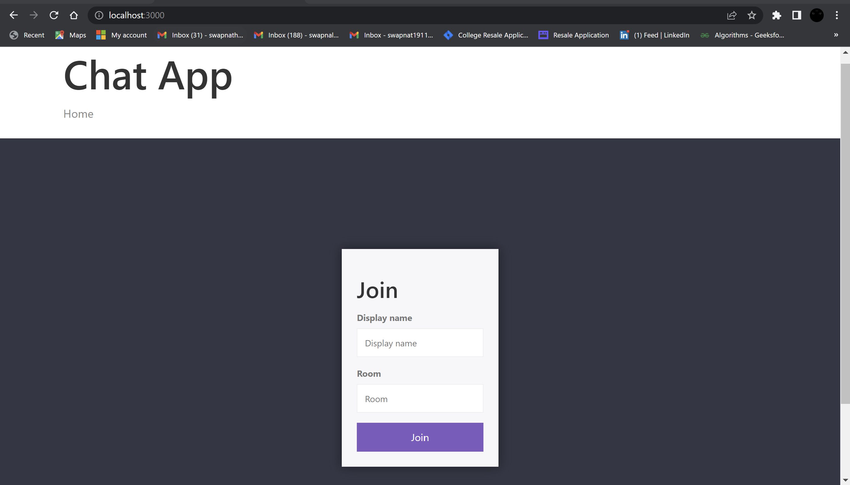

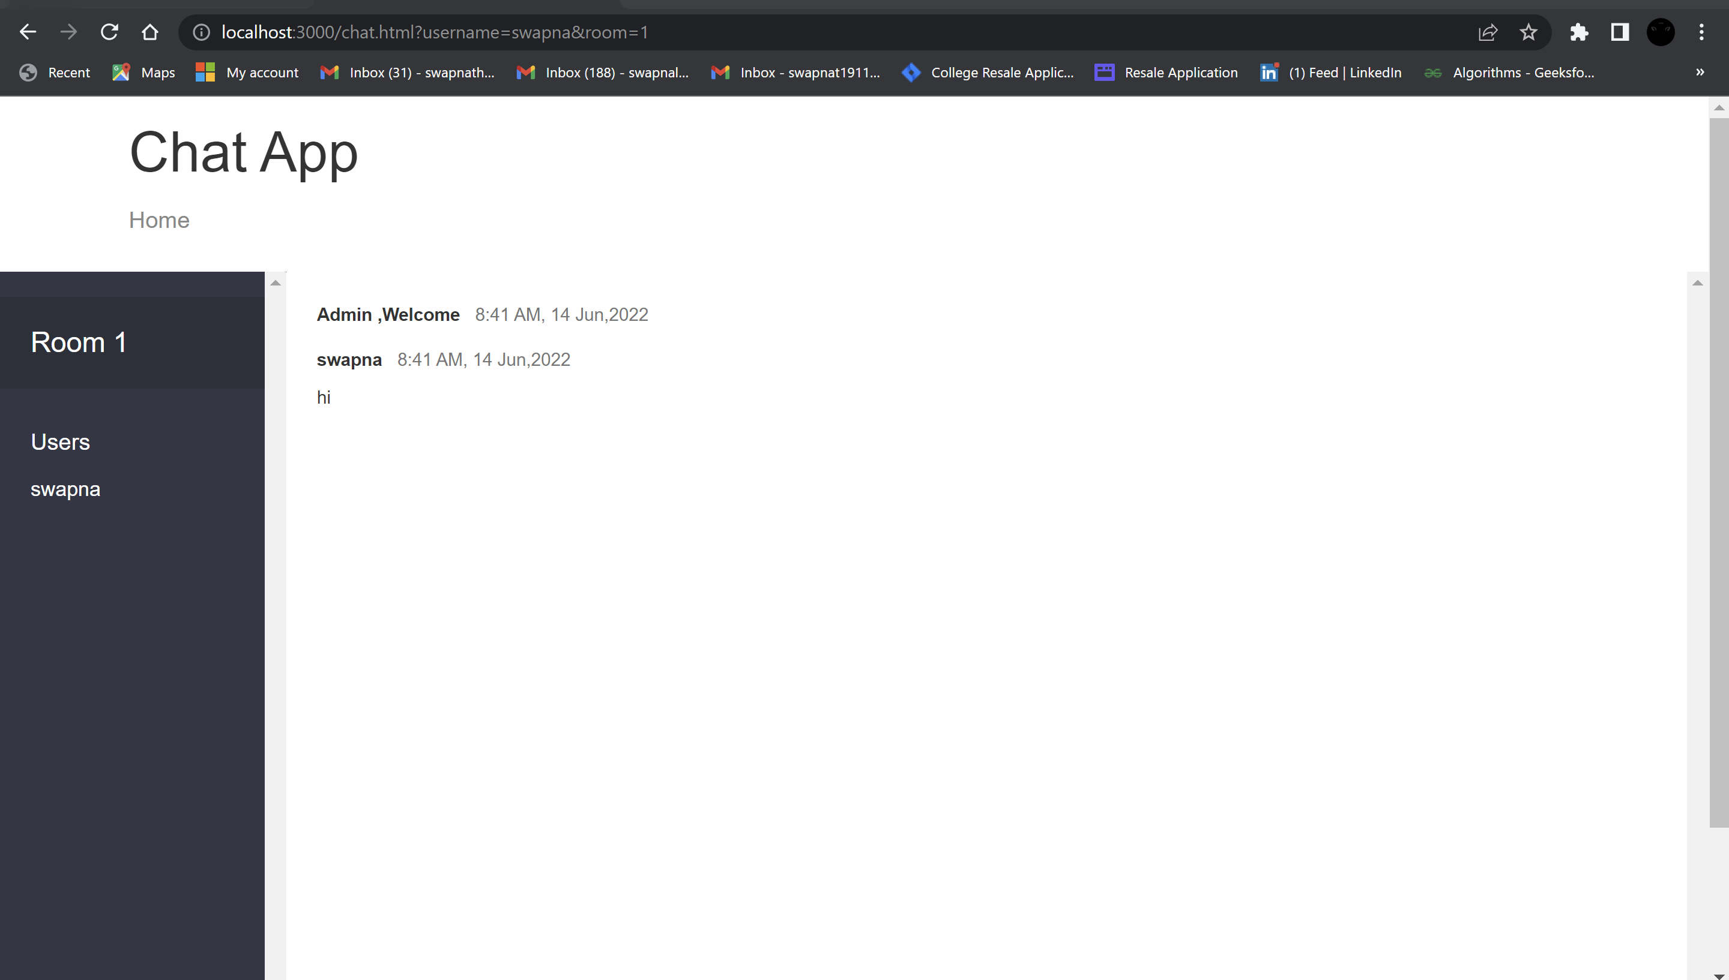

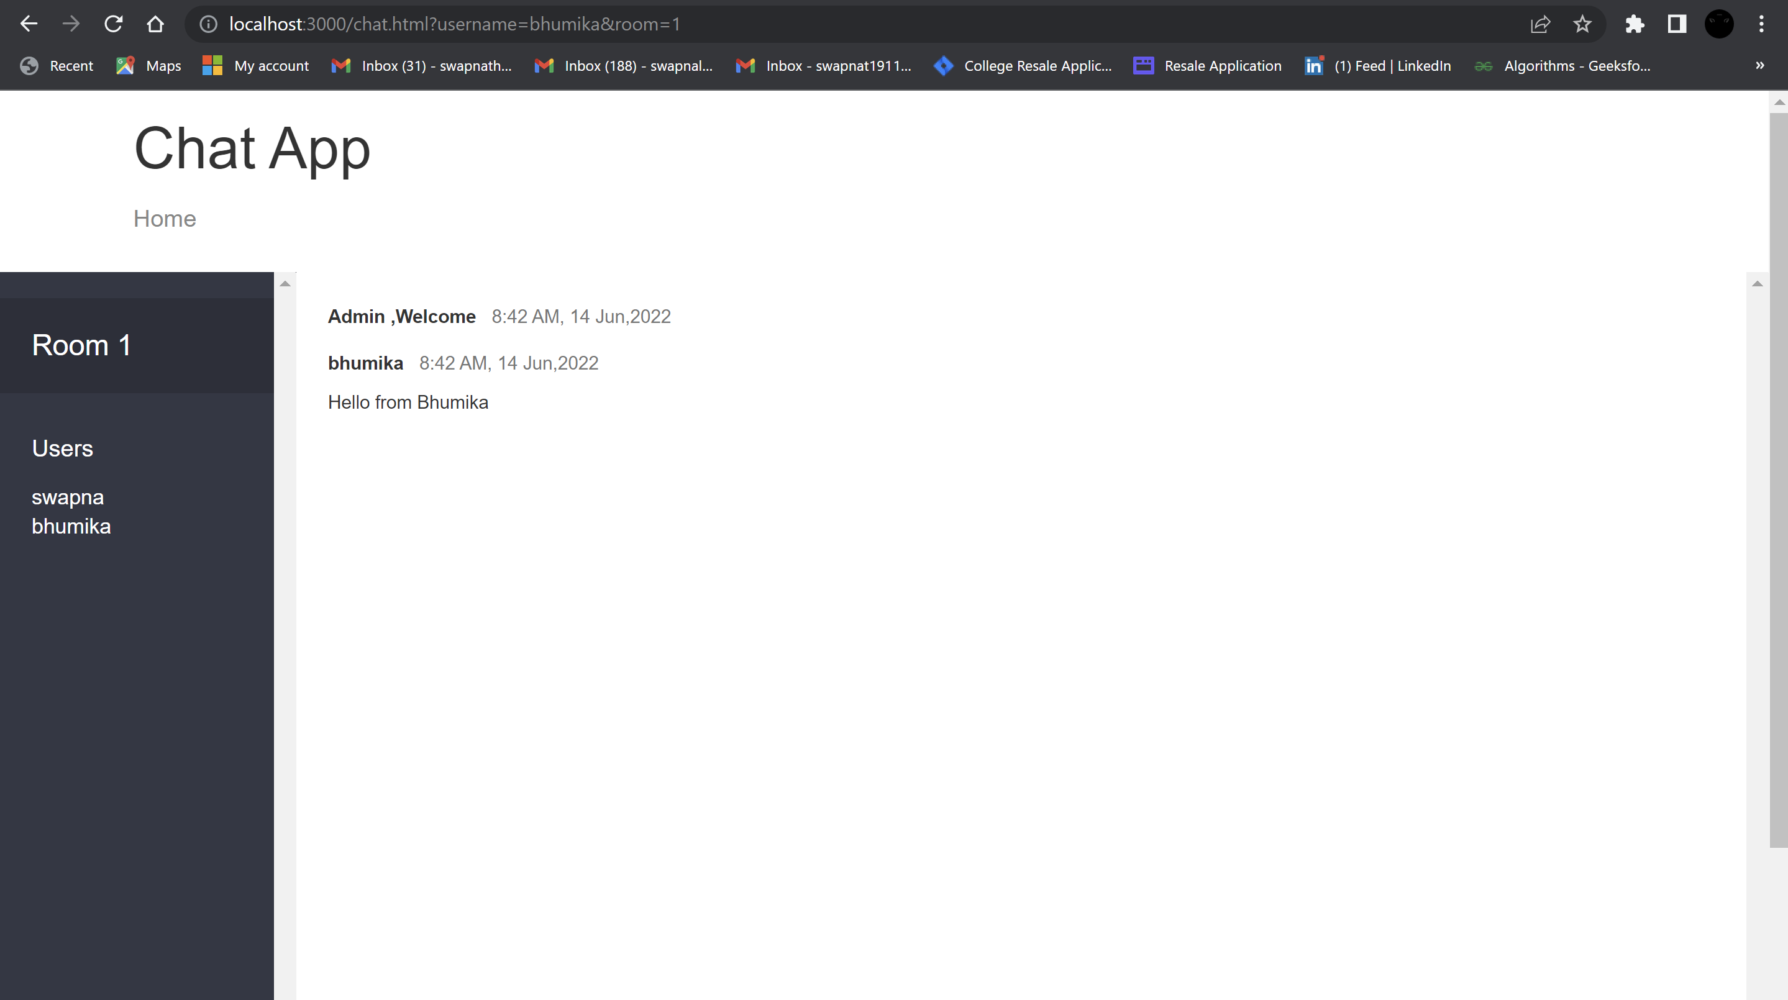

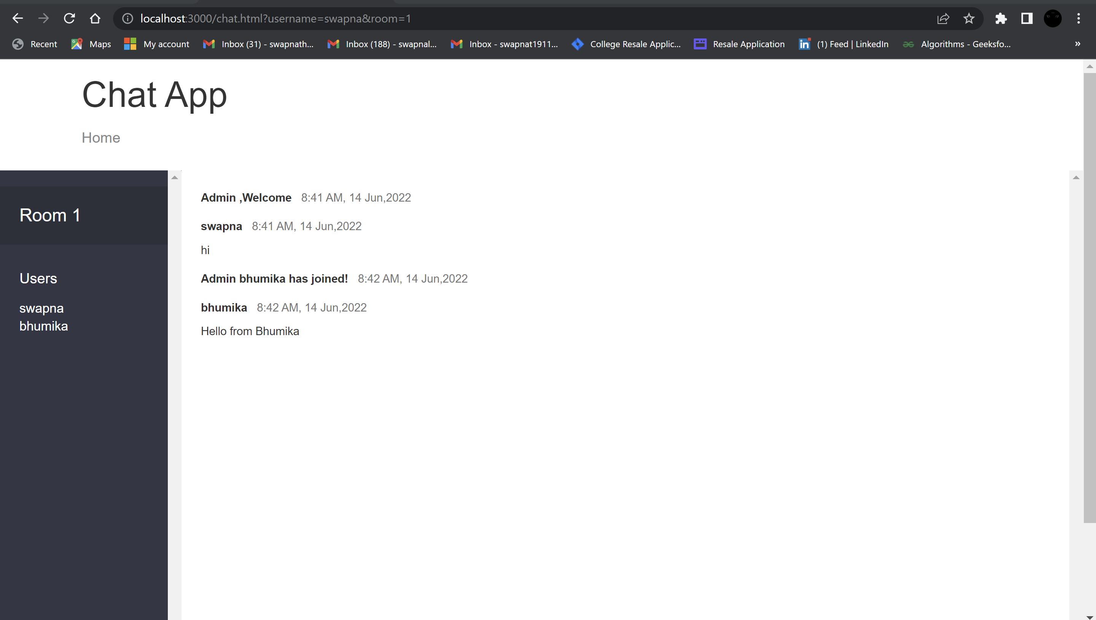

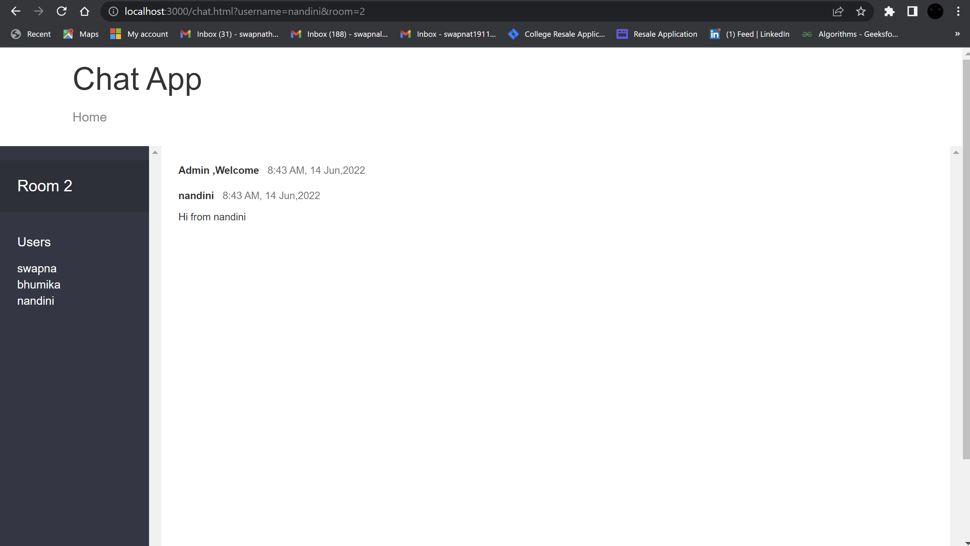

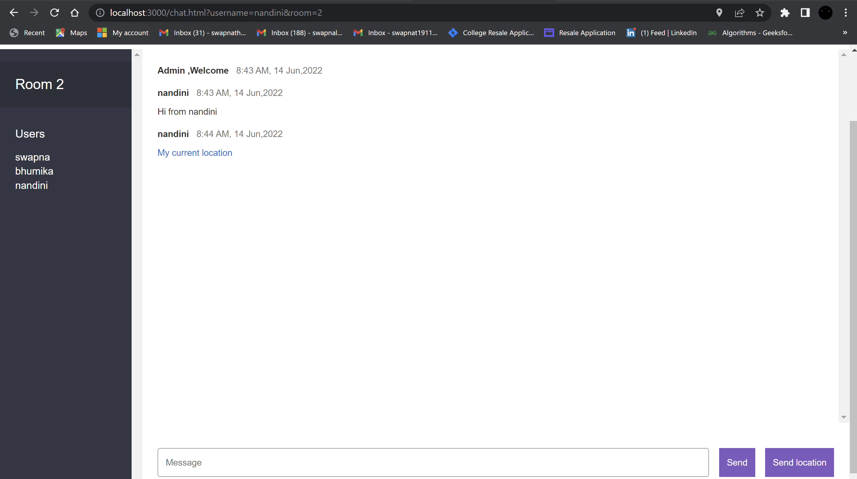

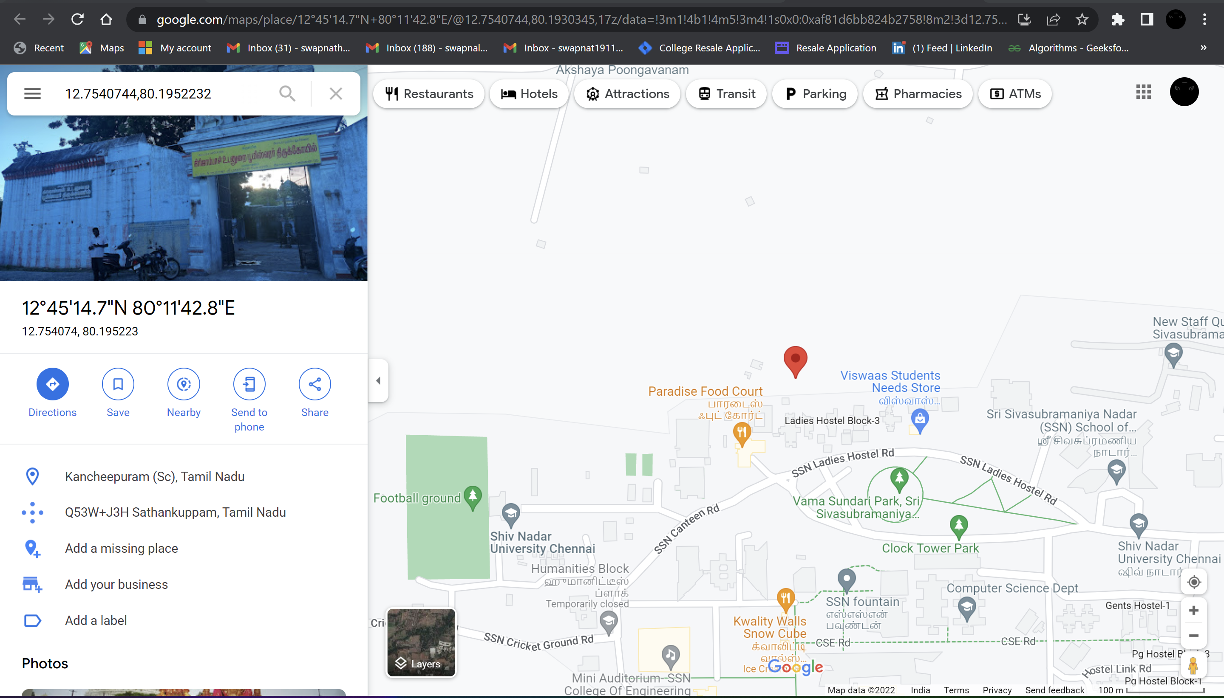

**Result:**

The above codes have been successfully executed to implement the Multi room chat application.

# **RESTful web service for Calculator Application**

**Exercise-12**

**Date:13-06-2022**

**Aim:**

To implement RESTful web service for Calculator Application.

**Procedure:**

• Initialise our Angular JS applications using ‘ng-app’ and use ‘ng-controller’ directive to control the the data (operand and operator ) of angular application

• REST- represents the architectural styles for implementing web service using http protocol.

• We identify each RESTful web service using an unique URL.

• We cache the result of particular operation using the GET method - app.get("/add", (req, res) {}

• We use HTTP methods like get,post,put to implement the concept of rest architecture.

• Use URI- uniform resource identifier which provides resource representation such as JSON and set of HTTP methods.

• Use JSON.stringify() method to convert a JavaScript object or value to a JSON string.

**Code:**

**Calc.html**

<!DOCTYPE html>

<html lang="en">

<head>

<meta charset="UTF-8">

<title>Calculator</title>

<link rel="stylesheet" href="styles.css">

</head>

<body>

<script src="https://ajax.googleapis.com/ajax/libs/angularjs/1.3.14/angular.min.js"></script>

<center>

<h3 id='bordering' style="background-color: lightblue; width: 50%;">SIMPLE CALCULATOR</h3>

<div ng-app="CalculatorApp" ng-controller="CalculatorController" id='bordering' style="background-color:lightblue;width: 50%">

<p>Operand 1</p>

<p><input type="number" ng-model="first"></p>

<p>Operand 2</p>

<p><input type="number" ng-model="second"></p>

<p>Choose operation</p>

<p><select ng-model="operator">

<option value="add">+</option>

<option value="subtract">-</option>

<option value="multiply">*</option>

<option value="divide">/</option>

</select>

</p>

<button ng-click="calculate()">CALCULATE</button>

<p>ANSWER</p>

<p ng-model="answer">{{answer}}</p>

</div>

</center>

<script>

angular.module('CalculatorApp', [])

.controller('CalculatorController', function ($scope, $http) {

$scope.calculate = function () {

ops = $scope.operator;

$http.get(ops,

{

params: {

first: $scope.first,

second: $scope.second

}

}).success(function (res) {

console.log('Exit status ' + JSON.stringify(res));

$scope.answer = res.result;

});

};

});

</script>

</body>

</html>

**Calchost.js**

const express = require("express");

const app = express();

app.use(express.static("public"));

app.get("/", (req, res) => {

res.sendFile(__dirname + "/calc.html");

});

app.get("/add", (req, res) => {

var first = req.query.first;

var second = req.query.second;

var value = Number(first) + Number(second);

var result = {result: value};

res.send(result);

});

app.get("/subtract", (req, res) => {

var first = req.query.first;

var second = req.query.second;

var value = Number(first) - Number(second);

var result = {result: value};

res.send(result);

});

app.get("/multiply", (req, res) => {

var first = req.query.first;

var second = req.query.second;

var value = Number(first) * Number(second);

var result = {result: value};

res.send(result);

});

app.get("/divide", (req, res) => {

var first = req.query.first;

var second = req.query.second;

var value = Number(first) / Number(second);

var result = {result: value};

res.send(result);

});

app.listen(7000);

**Output:**

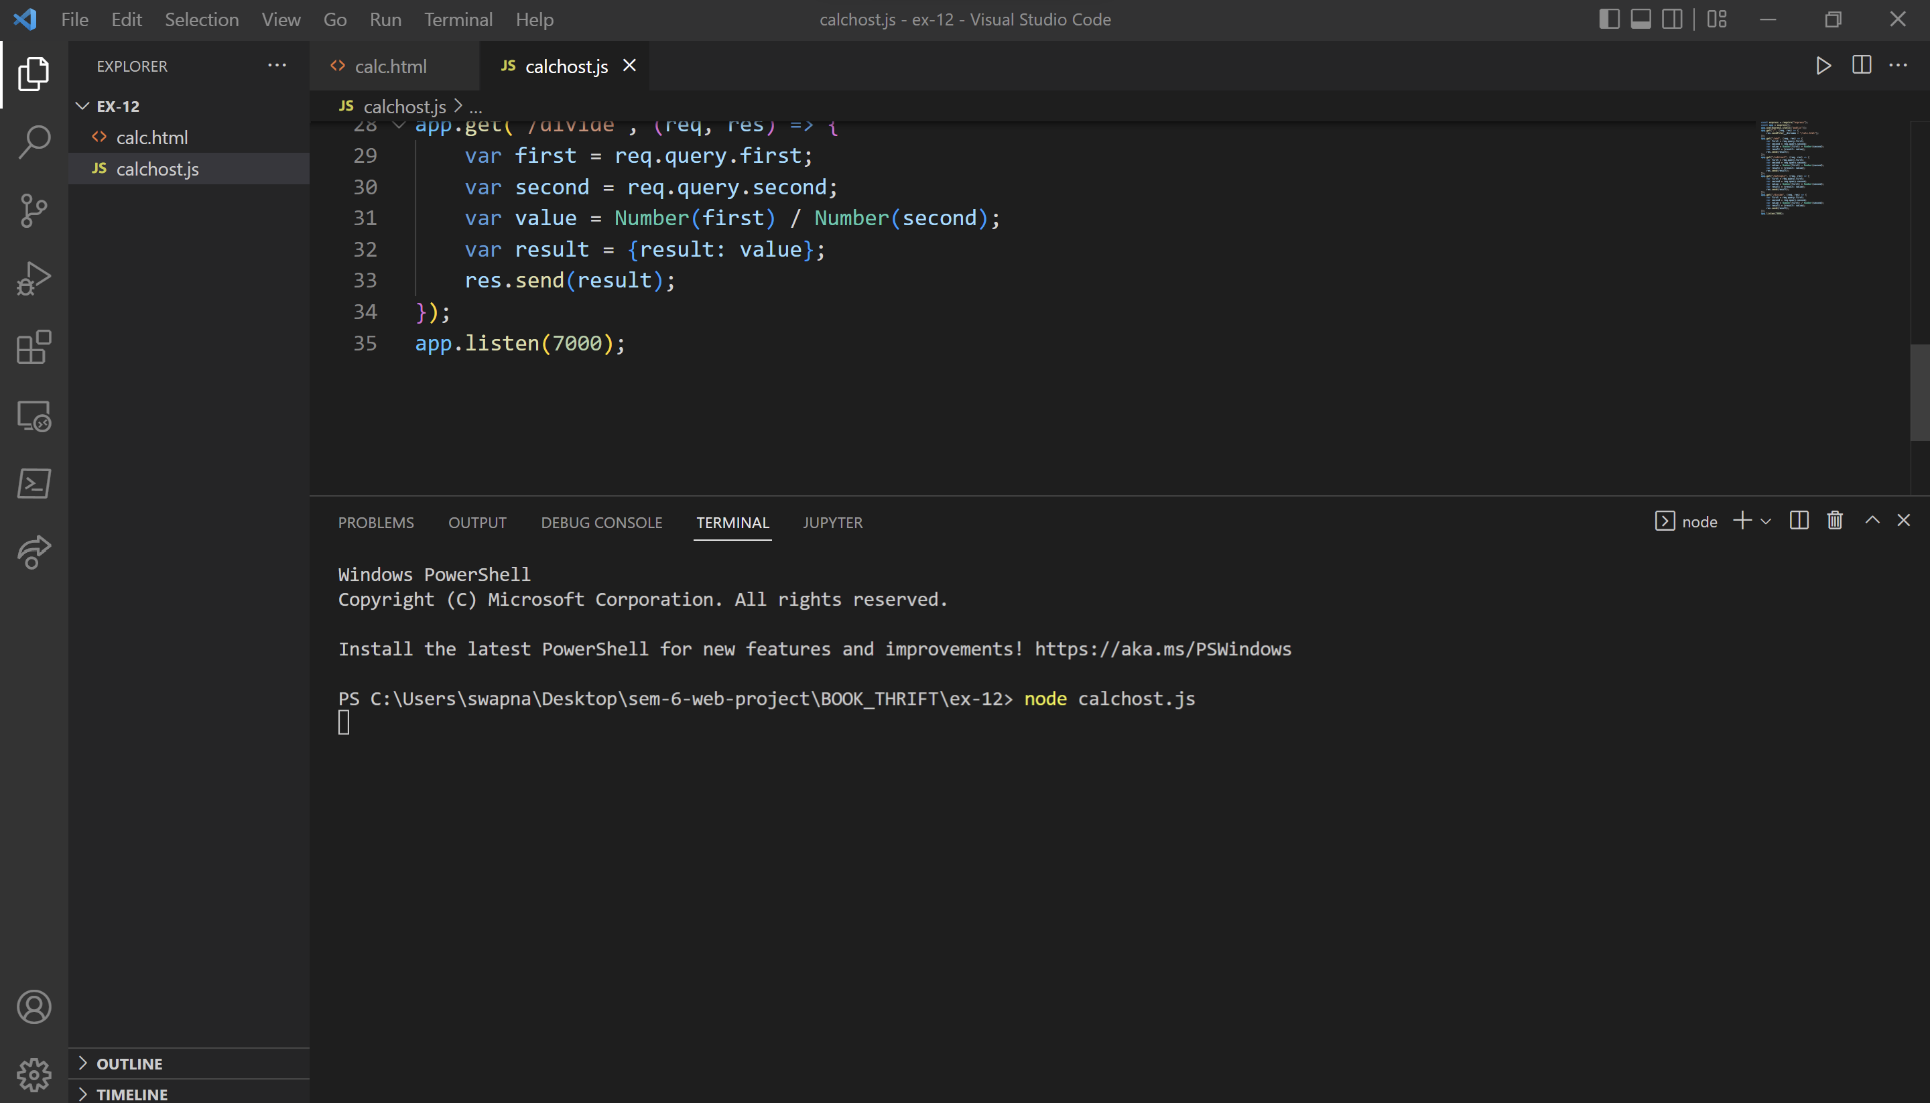

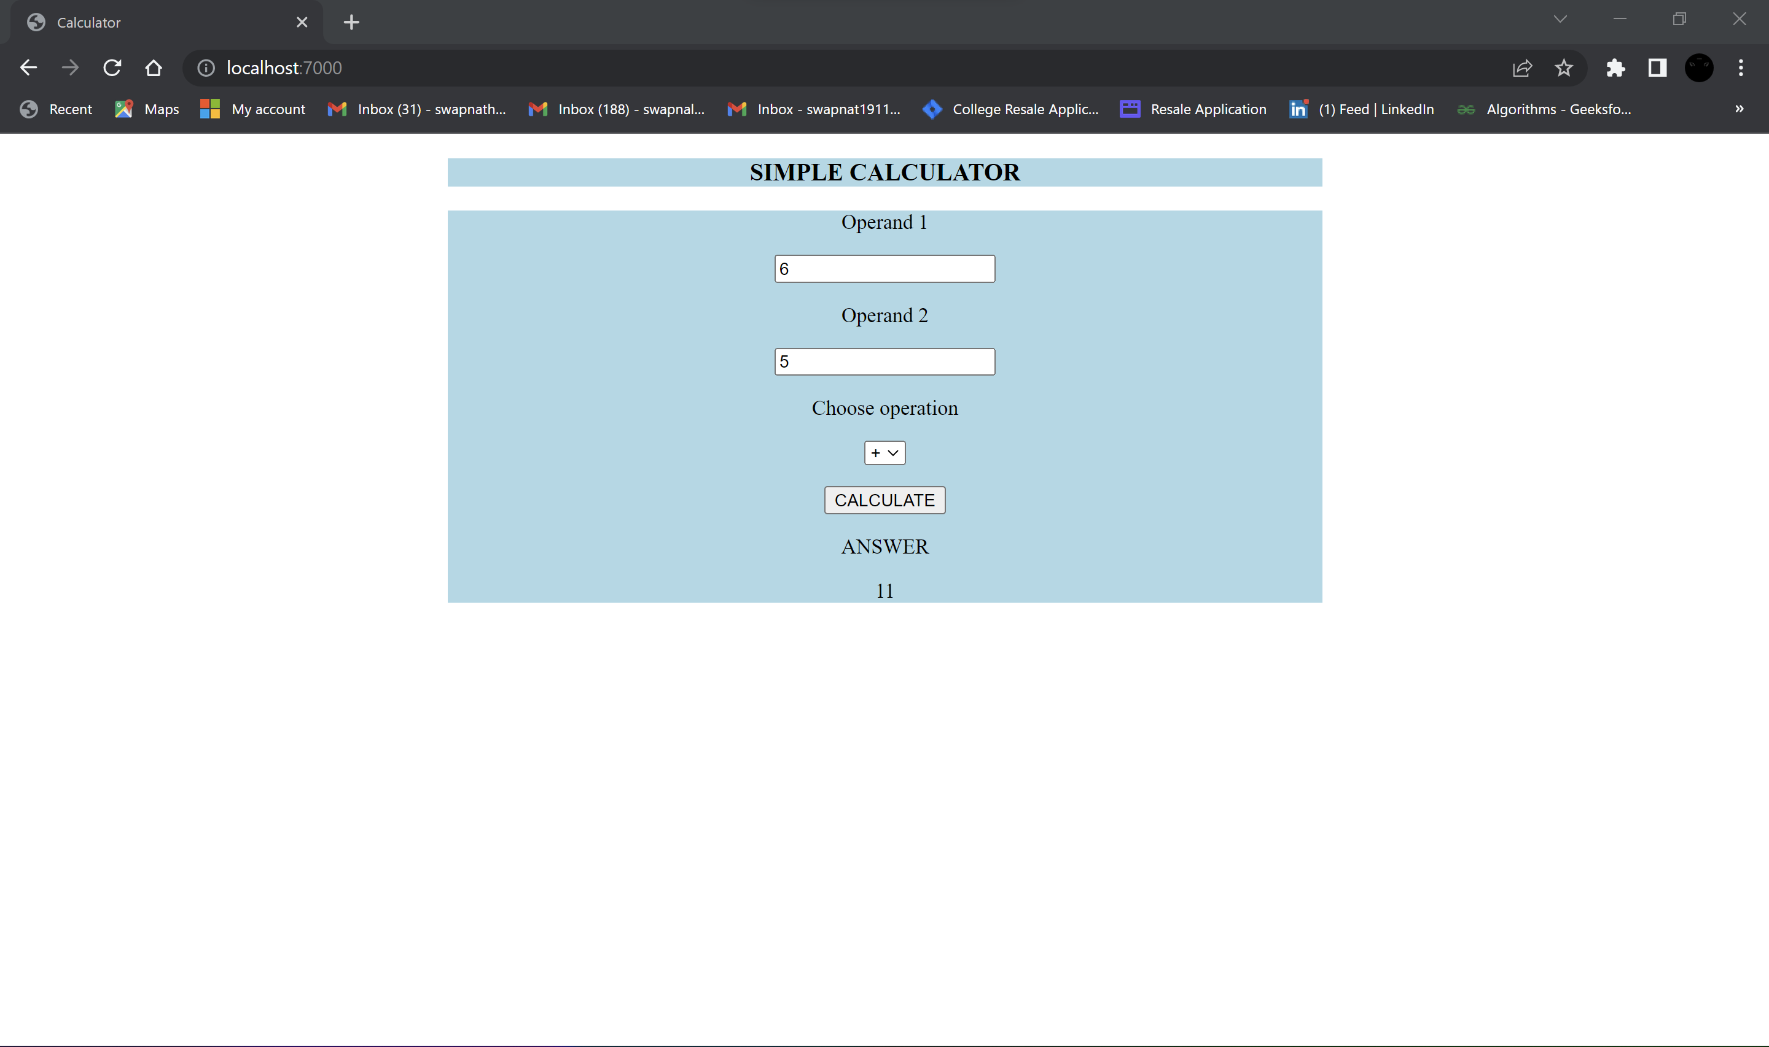

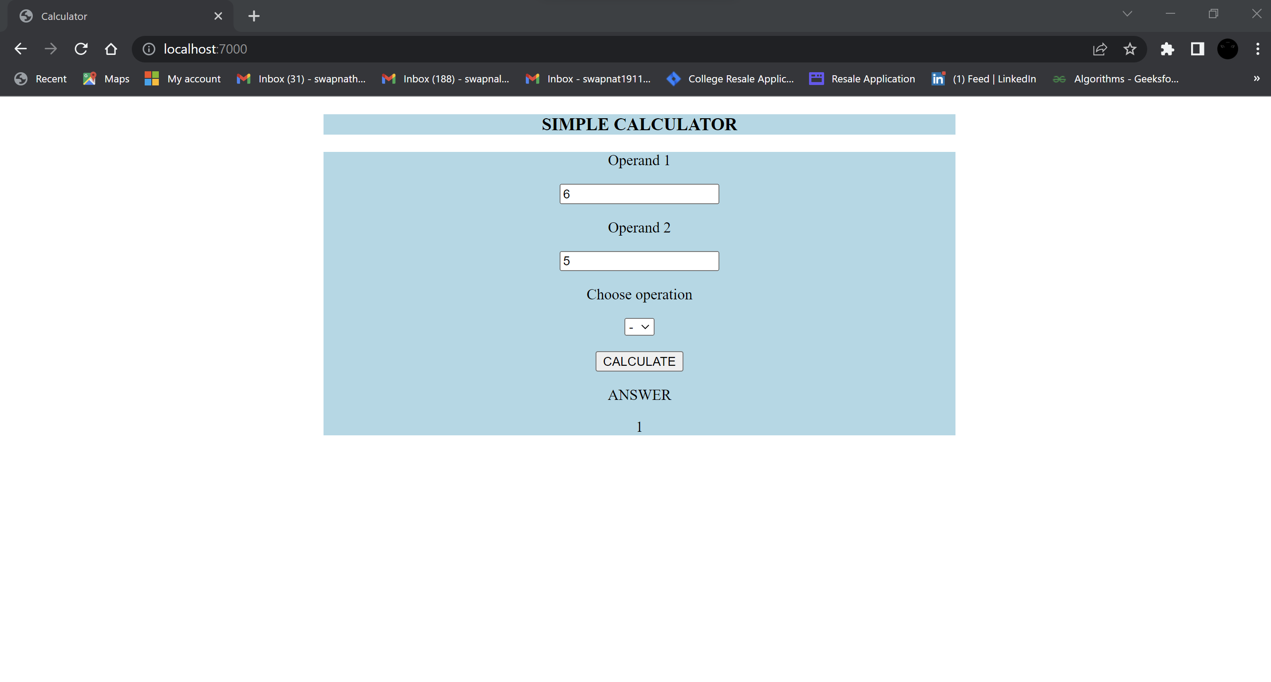

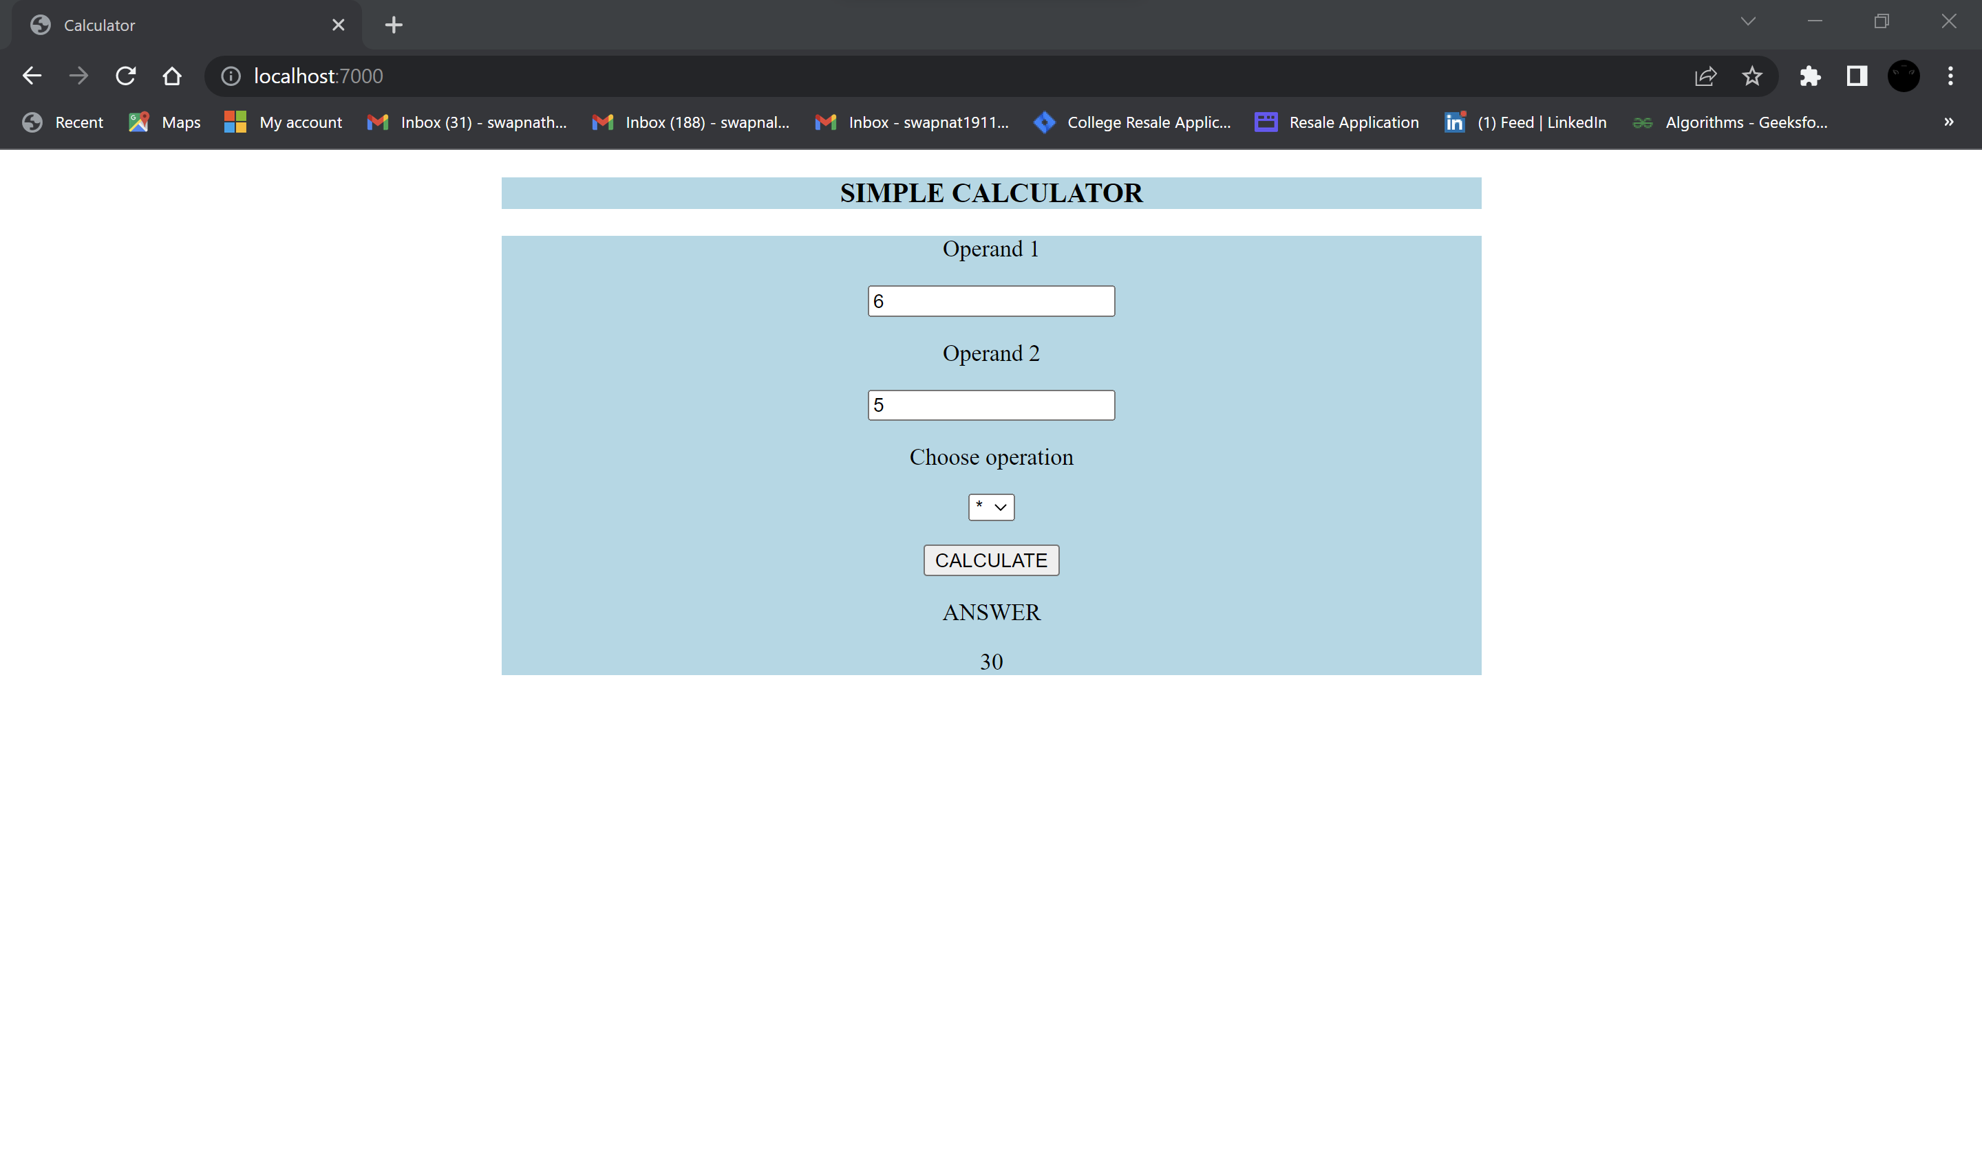

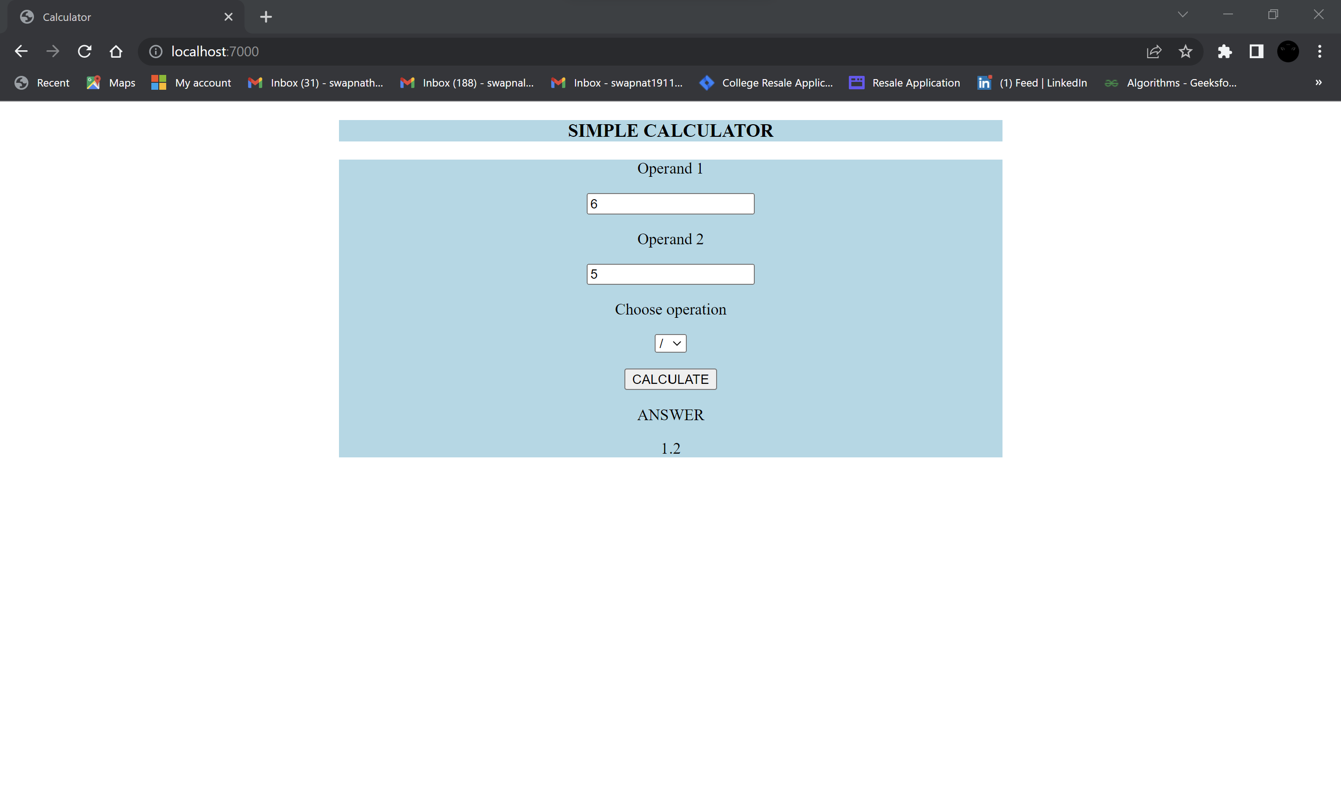

**Result:**

Thus, RESTful web service for calculator application is implemented successfully.